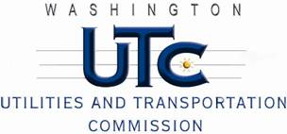

Memorandum

February 3, 2011

To: TR-100193 - File

From: Kathy Hunter, Deputy Assistant Director Transportation Safety

Subject: TR-100193 City of Auburn

Grade Crossing Protective Fund (GCPF) Traffic Signal Battery Back-up Projects at the Intersections of West Main and C Street Southwest, 3rd and C Street Northwest and 37th and B Street Northwest and BNSF Railway’s Tracks in the City of Auburn, Washington

On February 26, 2010, the Washington Utilities and Transportation Commission (Commission) awarded a GCPF grant totaling $20,000 to install battery back-up power systems for the traffic signals at three crossing with interconnection between railroad and traffic signals. The total cost of the project was estimated at $39,600 with the City of Auburn paying for costs over $20,000. The three crossings are located within the City of Auburn at:

* West Main and C Street Southwest USDOT #085655A
* 3rd and C Street Northwest USDOT #085652E
* 37th and B Street Northwest USDOT #085647H

On January 31, 2011, the applicant, the City of Auburn submitted a request for reimbursement pursuant to Commission order. Along with the request for reimbursement, the City of Auburn provided photographic documentation of the installation of the battery back-up power systems at all three crossings. The project is completed according to the specifications outlined in the order approving the grant.

Please close this docket.