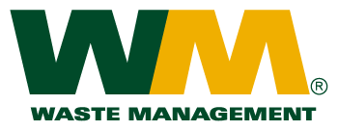

August 18, 2010

Washington Utilities and Transportation Commission

Chandler Plaza Building

1300 S. Evergreen Park Drive SW

P.O. Box 47250

Olympia, WA. 98504-7250

Dear Sirs:

Subject: Waste Management of Skagit County, a division of Waste Management of Washington, Inc. (G-237); Tariff #17

Enclosed are revised tariff pages 2 and 36 for the above-referenced tariff. The purpose of this filing is to remove the 40 and 50-yard drop box rates from the tariff, as these container sizes are not available nor have been requested by our customers. We request an effective date of October 2, 2010 for this filing.

If you have any questions or need additional information, please contact me at (425) 814-7840.

Very truly yours,

Michael A. Weinstein

Senior Pricing Manager, Pacific Northwest Market Area

cc: Elena Araujo