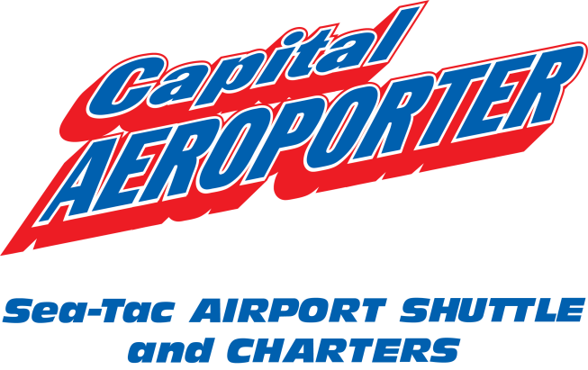

**NOTICE TO OUR VALUED CUSTOMERS**

November 19, 2013

Recent rule changes implemented by the Washington Utilities and Transportation Commission (WUTC) allow transportation companies to offer flexible fares on regulated services based on currently filed and approved fixed rates. The rule changes allow for a maximum increase of 25% over current rates and the lowest rate being reduced to $0.01.

Capital Aeroporter has submitted a request to the Washington Utilities and Transportation Commission to apply the new rule change to our existing fares to be effective December 19, 2013 (last updated in March 2006). We have also requested a less than statutory notice of change to be effective November 29, 2013.

These changes are pending approval. Please visit [www.capair.com](http://www.capair.com) for the complete list of our current fares.

Contact us at (360) 754-7113 x105 or x106 with questions or comments, or email [customerservice@capair.com](mailto:customerservice@capair.com). To contact the WUTC to comment or oppose, call 360-664-1160, email [consumer@utc.wa.gov](mailto:consumer@utc.wa.gov) or mail to Washington Utilities and Transportation Commission, 1300 S Evergreen Park Drive SW, PO Box 47250, Olympia, WA 98504-7250.

*We appreciate your loyalty to Capital Aeroporter to serve your transportation needs for over 40 years. Thank you for your continuing to support our local business and economy. We promise to continue to provide safe and friendly service!*

Capital Aeroporter

PO Box 2163

Olympia, WA 98507