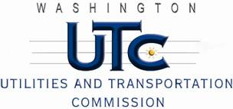

Memorandum

July 8, 2013

To: TR-121780 - File

From: Kathy Hunter, Rail Manager

Subject: TR-121780 City of Pasco (City)

Grade Crossing Protective Fund (GCPF) at the West A Street

USDOT #089707D

On November 29, 2012, the Washington Utilities and Transportation Commission (Commission) awarded the City a GCPF grant in the amount of $25,000 to improve safety at the South 1st and A Street crossing in Pasco. The City proposed to install median barriers on approaches to the crossing. The estimated project cost was $66,000, with the City paying for all costs exceeding $25,000.

On June 27, 2013, the applicant, the City, submitted a request for reimbursement for work pursuant to Commission order. In addition to the reimbursement request, the City provided photos of the crossing which verify that the project was completed according to the specifications outlined in the order approving the grant.

Please close this docket.