***CERTIFICATION***

I am Vice President – Regulatory Operations for the CenturyLink Operating Companies together with Qwest Corporation d/b/a CenturyLink QC (CenturyLink). I have overall responsibility for supervision of the personnel who prepared all of the data supporting CenturyLink’s annual access charge tariff filings with the Federal Communications Commission (FCC) and I am authorized to execute this certification. I provide this certification based upon the information provided to me by employees responsible for the preparation of the data submitted in support of CenturyLink’s 2012 FCC annual access charge tariff filings. I hereby certify, pursuant to 47 C.F.R 51.915(d)(3), that CenturyLink is not seeking duplicative recovery in the state jurisdiction for any Eligible Recovery subject to the recovery mechanism established by the FCC’s November 18, 2011 USF ICC Transformation Order, FCC 11-161 (WC Docket No. 10-90).

June 28, 2012

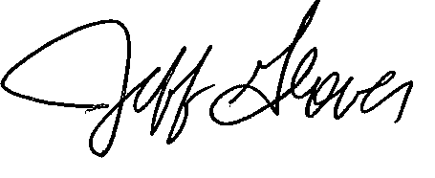

Jeff Glover

Vice President – Regulatory Operations

Contact Person: Gary Kepley

Director, Regulatory Operations

Telephone Number: (913) 345-7572