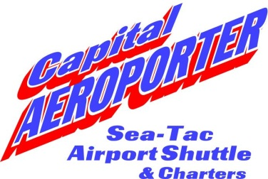
Customer Notice

Capital Aeroporter Airport Shuttle has filed for a schedule change, with the Washington Utilities and Transportation Commission, to be effective on September 1, 2011. A Less Than Statutory Notice has also been filed to request the changes go into effect, as of August 14, 2011. The changes in the schedule will provide the general public more options and scheduled shuttles to travel to/from the Seatac International Airport.

Capital Aeroporter Airport Shuttle
Pacific Northwest Transportation Services, Inc.

Certificate No. 862

Schedule of Door-to-Door Share Ride Passenger
Service in the following described territory:

Between Seatac International Airport and points served in King, Pierce, Thurston, Mason, Lewis and Grays Harbor Counties

Issued by:
James N. Fricke, President
PO Box 2163
Olympia, WA 98507
2745 29th Ave SW #B
Tumwater, WA 98512
Phone: (360) 754-7113
Fax: (360) 754-7118

This notice has been posted in compliance with regulations of the Washington Utilities and Transportation at 1300 S Evergreen Park Dr SW, Olympia, WA 98504. For more information you may contact Capital Aeroporter at 360-754-7113, PO Box 2163, Olympia, WA 98507 OR send comments to Washington Utilities Transportation Commission, 360-753-6423, 1300 S Evergreen Park Dr SW, Olympia, WA 98504.

