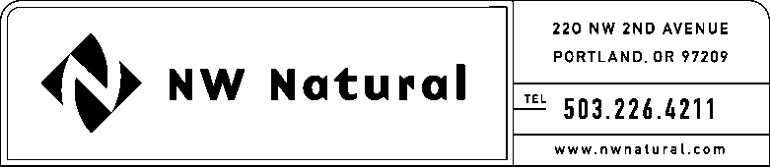

KYLE WALKER, CPA
Rates/Regulatory Analyst
Tel: 503.226.4211 ext. 5858
Fax: 503.721.2516
email: kyle.walker@nwnatural.com
November 14, 2016

Steven V. King, Executive Director and Secretary
Washington Utilities & Transportation Commission
1300 South Evergreen Park Drive, SW
Post Office Box 47250
Olympia, Washington 98504-7250

RE: NW Natural’s Third Quarter of 2016 Results of Operations

Dear Mr. King,

Per WAC 480-90-275, attached are an original and two copies of the Company’s Results of Operations for the Third Quarter (July - September) 2016.

Included within each month’s section is a summary of the rate of return on rate base, an income statement presentation of results, a report of operations and maintenance expense broken out by FERC account and a detailed report of operations and maintenance expense which shows the allocation methodology used. Each month’s section also includes a report for the 12 months ending each month on the rate of return on rate base and the income statement presentation of results.

Also attached are a report of allocation factors and a report of gross plant and accumulated depreciation at December 31, 2014 and 2015. Finally, volumes, customers and use per customer are presented on monthly and 12-months ended bases for 2015 and first six months presentation 2016.

Reports are presented with system results, as well as with results for each state.

Please feel free to call or email me if you have any questions.

Sincerely,

/s/ Kyle Walker, CPA

Kyle Walker, CPA
Rates Analyst

Attachment: Quarterly Results of Operations Report to the WUTC – 3nd Quarter

