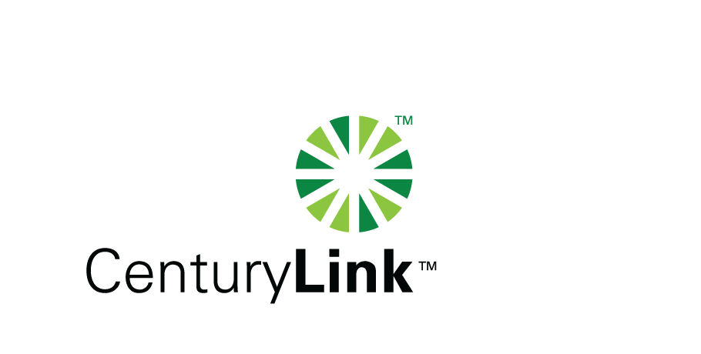

December 9, 2014

Steven V. King, Executive Director & Secretary

Washington Utilities & Transportation Commission

1300 S Evergreen Park Drive, SW

Olympia, Washington 98504-7250

Re: Washington Quality of Service Report for CenturyTel, Docket No. UT-921192.

Dear Mr. King:

Attached is the CenturyTel Service Quality Report d/b/a CenturyLink for the month of November, 2014. The trouble reports per 100 access lines objective was met for the month of November with the exceptions of Orting at 5.4, Vashon at 6.7, Wilbur 4.9. Orting received 19 tickets for deteriorated cable and drops. Vashon received 16 tickets due to inclement weather impacting cable and Wilbur received 5 tickets for cut cable.

Please note that some of the attached information is confidential pursuant to WAC 480-07-160 as it is competitively sensitive. It is marked as required under the rule and redacted copies are also provided.

If you should you have any questions, please contact Mark Reynolds at (206) 345-1568 or by e-mail at Mark.Reynolds3@Centurylink.com.

Sincerely,

Mark Reynolds

Enclosures: Installation/Repair Appointments

Service Activation in 5 Days

Trouble Per 100/Access Lines

Switching – Dial Tone Speed in 3 Seconds

Final Trunk Blockage (EAS and Toll)

Out of Service Trouble Cleared in 48 Hours

Not Out of Service Trouble Cleared in 72 Hours

Service Activation Delay 90-180 Days