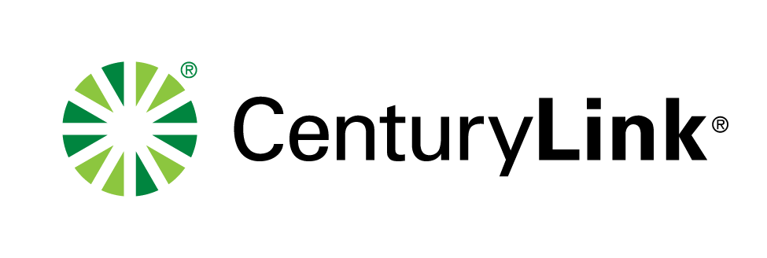

**ELECTRONIC FILING**

March 14, 2017

Mr. Steven King

Executive Director and Secretary

1300 S. Evergreen Park Dr. S.W.

P.O. Box 47250

Olympia, Washington 98504-7250

RE: **Do Not Redocket – Docket No. UT-170139**

Advice No. WA17-02A for United Telephone Company of the Northwest d/b/a CenturyLink

Dear Mr. King:

Attached for filing is a substitute sheet originally submitted in the above referenced docket number for Access Service Tariff WN U-11 for United Telephone Company of the Northwest d/b/a CenturyLink. Per discussions with Staff, the substitute sheet will clarify the proposed language. The sheet is:

**ACCESS SERVICE TARIFF**

**WN U-11**

|  |  |  |
| --- | --- | --- |
| **SECTION** | **SHEET** | **REVISION** |
| 2 | 26 | 1st |

I, Debra Levy, in compliance with WAC 480-80-103, certify that I have authority to issue tariff revisions on behalf of United Telephone Company of the Northwest d/b/a CenturyLink.

The proposed effective date is April 1, 2017.

If you have questions concerning this filing, you may contact me at the phone number or email address listed below or Phil Grate at (206) 345-6224.

Sincerely,

Debra Levy

Manager Regulatory Operations

Enclosures

ec: Phil Grate, CenturyLink

John Felz, CenturyLink

**DEBRA LEVY**

Debra.Levy@CenturyLink.com

600 New Century Parkway

New Century, KS 66031

Voice: (913) 353-7088

WA17-02A