# ONITA R. KING

Rates and Regulation

Tel: 503.721.2452

Fax: 503.721.2516

Email: ork@nwnatural.com

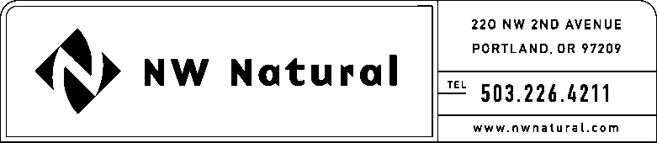

April 27, 2015

Steven V. King, Executive Director and Secretary

Washington Utilities & Transportation Commission

1300 S Evergreen Park Drive, SW

### Post Office Box 47250

Olympia, Washington 98504-7250

**Re: 2014 Essential Utilities Services Contracts Report**

Northwest Natural Gas Company, dba NW Natural (“NWN” or the “Company”) files herewith its Essential Utilities Services Contracts Report for 2013 pursuant to WAC 480-90-268, adopted by the Commission in Order No. R-518, dated February 28, 2005.

The Company considers this document to be confidential, and hereby requests that it be accorded confidential treatment in accordance with RCW 80.04.095 and WAC 480-07-160. No portion of these materials may be copied, reproduced, or disclosed in any manner without the express permission of NW Natural.

Please contact me should you have questions or require additional information.

Sincerely,

Onita R. King

Rates & Regulation

enclosures

ORK/sls