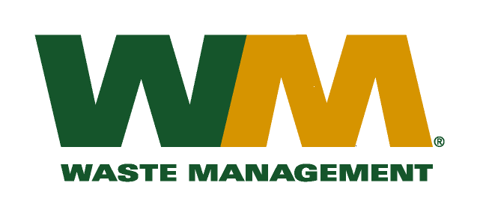

September 14, 2009

Washington Utilities and Transportation Commission

Chandler Plaza Building

1300 S. Evergreen Park Drive SW

P.O. Box 47250

Olympia, WA 98504-7250

Subject: Waste Management – South Sound and Waste Management of Seattle, a division of Waste Management of Washington, Inc. (G-237); Tariff # 21

Dear Sirs:

Enclosed are the revised tariff pages 2 and 20 to the above-referenced tariff. The purpose of these tariff revisions is to eliminate the service and related rates associated with this activity. Due to inherent risk of injury to our drivers, we have determined that we can no longer offer this service to our customers. We currently have only one customer receiving this service however upon investigation we discovered that they have not been previously billed for this activity. We will be notifying the customer of our decision to eliminate this service and our proposed tariff revision to reflect this change before September 30th. Our proposed effective date for this tariff revision is November 1, 2009. Also attached for your review is our proposed letter to our customer.

If you have any questions or need additional information regarding this filing, please contact me at (425) 814-7840.

Very truly yours,

Michael A. Weinstein

Senior Pricing Manager, Pacific Northwest Market Area

cc: Greg Hale