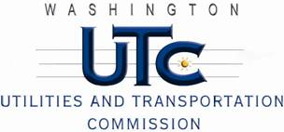

Memorandum

December 13, 2012

To: TR-121302 - File

From: Betty Young, Compliance Investigator, Transportation Safety

Subject: TR-121302 – Washington & Idaho Railway, Inc. (WIR)

Grade Crossing Protective Fund (GCPF) project to modify active warning devices at SR-272 in Palouse (USDOT 859334J)

On August 21, 2012, the Washington Utilities and Transportation Commission (Commission) awarded Washington & Idaho Railway, Inc. (WIR) a GCPF grant in the amount of $20,000 to improve modify active warning devices at SR-272 in Palouse (USDOT 859334J). The estimated project cost was $21,487.17 with WIR paying for all costs exceeding $20,000.

On December 11, 2012, WIR submitted a request for reimbursement for work pursuant to Commission order. Commission staff conducted a site visit of the crossing and verified that the project was completed according to the specifications outlined in the order approving the grant.

Please close this docket.