July 17, 2015

Mr. Steven King
Executive Director and Secretary
Washington Utilities and Transportation Commission
1300 South Evergreen Park Drive SW
Olympia WA 98504-7250

RE: 2015 ETC Certification and Reports – Request for Certification Pursuant to WAC 480-123-060 and 47 C.F.R. §54.314

Dear Mr. King:

Pursuant to WAC 480-123-060, YCOM Networks, Inc. d/b/a FairPoint Communications (“Company”) hereby requests that the Washington Utilities and Transportation Commission (“Commission”) certify to the Federal Communications Commission and the Universal Service Administrative Company that the Company has met the requirements of 47 C.F.R. § 54.314 for eligibility for continued receipt of federal high-cost funds.

The certifications and reports that are specified in WAC 480-123-060, WAC 480-123-070 and WAC 480-123-080 are enclosed.

Sincerely,
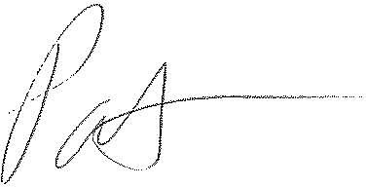
Patrick L. Morse
Senior VP Governmental Affairs
FairPoint Communications
P: 620-227-4409
F: 620-227-8576

