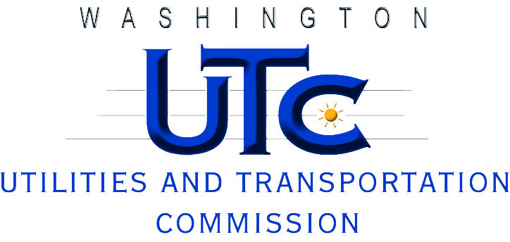

Investigation Report

Pullman Disposal Service, Inc.

TG-121205

Rayne Pearson  
Compliance Investigations

July 2012

**PURPOSE, SCOPE AND AUTHORITY**

**Purpose**

The purpose of this investigation is to determine if Pullman Disposal Service, Inc. (PDS) violated commission laws and rules when it overcharged 23 customers for a ten-month period. The Revised Code of Washington (RCW) 81.28.080 states that common carriers shall not charge, demand, collect or receive a greater, less or different compensation for services than those filed with the commission and in effect at the time. Washington Administrative Code (WAC) 480-70-236 states that a company cannot assess rates and charges for solid waste collection services that are higher, lower or different from those contained in its tariff.

**Scope**

The scope of this investigation is limited to PDS’s self-reported overcharge, totaling $22,976 and affecting 23 customers between June 2011 and March 2012.

**Authority**

Staff undertakes this investigation pursuant to RCW 81.04.070. WAC 480-70-216 authorizes the commission to administer and enforce laws and rules relating to solid waste collection companies.

**Staff**

Rayne Pearson, Compliance Investigator

(360) 664-1111

rpearson@utc.wa.gov

**BACKGROUND**

**Company Information**

Pullman Disposal Service, Inc. is a for-profit corporation. Devon Felsted is the President, and William Felsted is the Vice-President. PDS provides solid waste collection services under a certificate of public convenience and necessity granted by the commission, G-42.

PDS collected $3.8 million in regulated revenue for 2011, and served approximately 12,000 residential and commercial garbage collection customers in Washington. PDS currently provides service according to Tariff No. 17, effective April 1, 2012.

**Investigation**

This investigation was prompted by a self-reported overcharge that occurred due to a change in billing software.

**INVESTIGATION**

On May 30, 2012, PDS contacted commission staff to report an inadvertent overcharge affecting 23 customers. Judy Druffel, the company’s office manager, sent the following email to staff:

“This April  when we were putting the new UTC rates from our rate increase into the computer, we found a large error in 23 of our customer accounts.  We had been charging these customers double for their recycling service.  Some accounts have been charged as of June, 2011, and the others as of August, 2011, when they were restarting their service at the start of the WSU school year.  The software error happened when we transferred from our old software to our new software program. It affected only the recycling for multi-family customers with 8-yard containers. As of April all of the accounts have been corrected and are being charged the correct rate. The extra money generated from these errors each month was approximately $2,297.00.  The total amount  for the10 month period was $22,976.00.  This amount includes the taxes and fuel surcharge.  The money was deposited with the normal revenue from these accounts.  Our revenue fluctuates depending on several reasons.  One reason is the amount of extra garbage customers put out at the end and the start of the apartment leases.  Fraternities and Sororities preparing for special functions during the school year.  Also construction drop boxes used.  None of the customers that were affected noticed the increase in their bills.

Pullman Disposal would like to credit these accounts for the overcharges.  We will write each customer a letter and we are asking you if we could spread the credits over a 3 month period – July, August, and September.  One reason we are asking for the 3 months to credit their accounts is because our revenue is lower in June, July, and August. Thank you for your consideration of this matter.”[1]

In response to Ms. Druffel’s email, staff issued a data request on June 7, 2012, requesting the following information by June 14, 2012:

1. The number of customers impacted by the overcharge.
2. The remedy, if any, provided to the impacted customers.
3. An explanation of why the overcharge occurred, when and how it was discovered, and whether and when it was corrected.
4. The name, title, telephone number, and e-mail address of the Pullman Disposal, Inc. contact person that our staff can work with directly for questions that may arise concerning any details of the information you provide.[2]

On June 11, 2012, PDS responded to staff’s data request with an explanation that was substantially similar to Ms. Druffel’s email of May 30.[3]

**FINDINGS AND RECOMMENDATION**

**Findings**

Staff finds that PDS’s self-reported overcharge, totaling $22,976 and affecting 23 customers over a period of 10 months, constitutes 230 violations of WAC 480-70-236. WAC 480-70-236 provides that a solid waste company cannot charge rates for services that are higher, lower or different from those contained in its tariff.

**Recommendation**Staff recommends a $100 penalty for 23 violations of WAC 480-70-236, which represents one violation per affected customer, for a total penalty of $2,300. Staff believes that penalties for 23 violations—as opposed to 230 violations—is proportionately appropriate given the inadvertent nature of the violations, and that the company self-reported them.

Staff also recommends that the company refund its customers in the manner prescribed by WAC 480-70-406, which states: “once a company becomes aware that it has overcharged a customer, it must provide a refund or bill adjustment credit to the customer. The customer must be given a choice as to which option is preferred.” Staff requests that the company provide written confirmation of the refunds or credits once they are made.

**APPENDIX A**

**From:** Judy Druffel [mailto:judy@pullmandisposal.com]   
**Sent:** Wednesday, May 30, 2012 6:56 PM  
**To:** Stillwell, Suzanne (UTC)  
**Subject:** Overcharge of Customers

To Susan Stillwell,

This April  when we were putting the new UTC rates from our rate increase into the computer, we found a large error in 23 of our customer accounts.  We had been charging these customers double for their recycling service.  Some accounts have been charged as of June, 2011, and the others as of August, 2011, when they were restarting their service at the start of the WSU school year.  The software error happened when we transferred from our old software to our new software program. It affected only the recycling for multi family customers with 8 yard containers.

As of April all of the accounts have been corrected and are being charged the correct rate.

The extra money generated from these errors each month was approximately $2,297.00.  The total amount  for the10 month period was $22,976.00.  This amount includes the taxes and fuel surcharge.  The money was deposited with the normal revenue from these accounts.  Our revenue fluctuates depending on several reasons.  One reason is the amount of extra garbage customers put out at the end and the start of the apartment leases.  Fraternities and Sororities preparing for special functions during the school year.  Also construction drop boxes used.  None of the customers that were affected noticed the increase in their bills.

Pullman Disposal would like to credit these accounts for the overcharges.  We will write each customer a letter and we are asking you if we could spread the credits over a 3 month period – July, August, and September.  One reason we are asking for the 3 months to credit their accounts is because our revenue is lower in June, July, and August.

Thank you for your consideration of this matter.

Sincerely,

Judy Druffel  
Office Manager

**APPENDIX B**



**APPENDIX C**

1. A copy of the May 30, 2012, email from Ms. Druffel is attached as Appendix A.
2. A copy of the June 7, 2012, data request is attached as Appendix B.
3. A copy of the June 11, 2012, response to staff’s data request is attached as Appendix C.