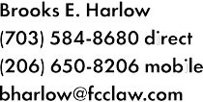  

 

þÿ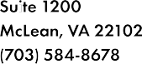January 27, 2016

**VIA WUTC WEB PORTAL**

Mr. Steven V. King

Executive Director and Secretary

Washington Utilities and Transportation Commission

P.O. Box 47250

Olympia, WA 98504-7250

**Re: 2016 FCC Form 555 Annual Lifeline ETC Report and Certification WUTC Docket No. UT-160028**

Dear Mr. King:

Submitted herewith for filing in Docket No. UT-160028 is a copy of United States Cellular Corporation’s 2016 Lifeline ETC annual filing to the Federal Communications Commission pursuant to 47 C.F.R. § 54.416 (b). A hard copy of this filing will not be provided, unless requested.

If you have any questions, please feel free to contact the undersigned.

Respectfully submitted,

Digital Signature - BEH

Brooks E. Harlow David A. LaFuria

*Counsel for United States Cellular Corporation.*

cc: Mr. Roger Hahn Enclosures