December 6, 2012

David W. Danner, Executive Director and Secretary
Washington Utilities and Transportation Commission
1300 S. Evergreen Park Dr. SW
P. O. Box 47250
Olympia, Washington 98504-7250

RE: Washington Utilities and Transportation Commission v. Norlight, Inc.
Commission Staff’s Response to Application for Mitigation of Penalties
Docket UT-120992

Dear Mr. Danner:

On July 31, 2012, the Washington Utilities and Transportation Commission issued a $2,100 Penalty Assessment in Docket UT-120992 against Norlight, Inc., (Norlight) for 21 violations of Washington Administrative Code (WAC) 480-120-382, which requires competitively classified telecommunications companies to furnish annual reports to the commission no later than May 1 each year.

On August 10, 2012, Norlight wrote the commission requesting mitigation of penalties (Mitigation Request). In its Mitigation Request, Norlight disputes the violations occurred. The company states, “The WUTC e-file confirmation is dated 5/4/2012. The Notice of Enforcement Action notified us of the mitigated penalty to $25 per day. This results in a $75 penalty due to the WUTC. I have attached the supporting documents for your records.” In a letter attached with its mitigation request, the company states, “We believe that a $75 penalty is due to the WUTC for 2011 annual report that was filed electronically on May 4, 2012. I have attached the check # 509034 for payment of fee along with WUTC e-file submission confirmation dated 5/4/2102, the Notice of Enforcement Action date 5/14/2012, and the 5/21/12 and 5/31/12 correspondence with Matthews Perkinson. Please note that his 5/31/12 [sic] is referring to the 5/21/2012 voicemail that he left me in response to my 5/21/2012 email.

On August 10, 2012, compliance staff received an email from Financial Services staff saying, “I missed this annual report. I thought it was the same Norlight Telecommunications, but it was actually Norlight Inc. She paid the $75 penalty today she should have accrued. I apologize. I missed it.”

Staff determined the completed annual report was, in fact, filed on May 4, 2012, which is three business days past the deadline of May 1, 2012. The penalty should have been mitigated from $100 per day to $25 per day, for a total of $75. Therefore, a penalty of $2,100 should not have been issued.

Based on the above mentioned information, staff recommends waiving any and all remaining penalties related to Norlight’s 2011 annual report.

If you have questions regarding this recommendation, please contact Mathew Perkinson, Compliance Investigator, at (360) 664-1105, or at mperkinson@utc.wa.gov.

Sincerely,

Sharon Wallace, Assistant Director
Consumer Protection and Communications

Attachment A

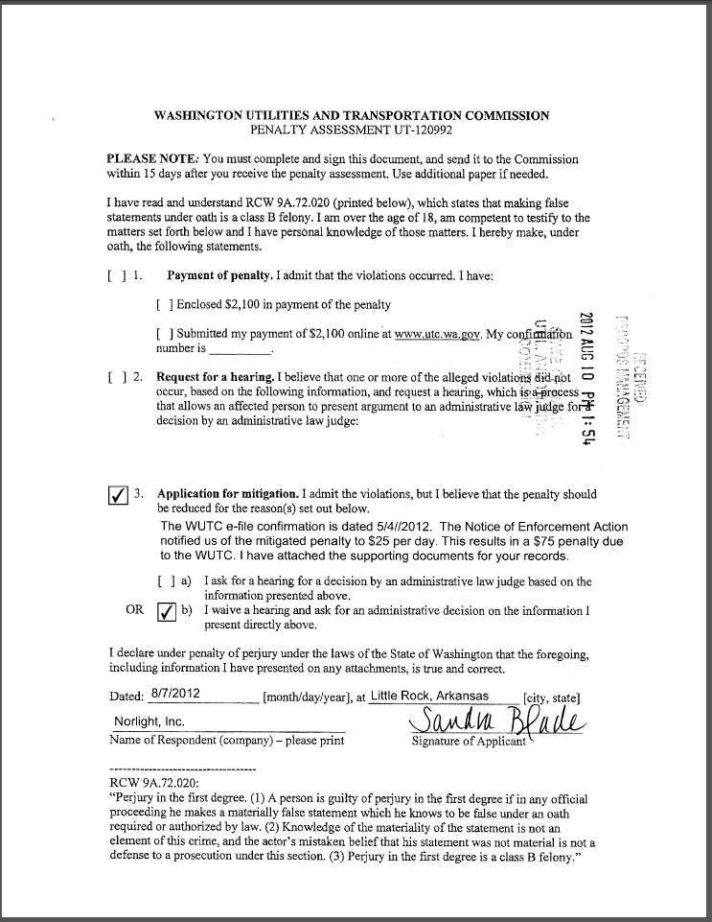

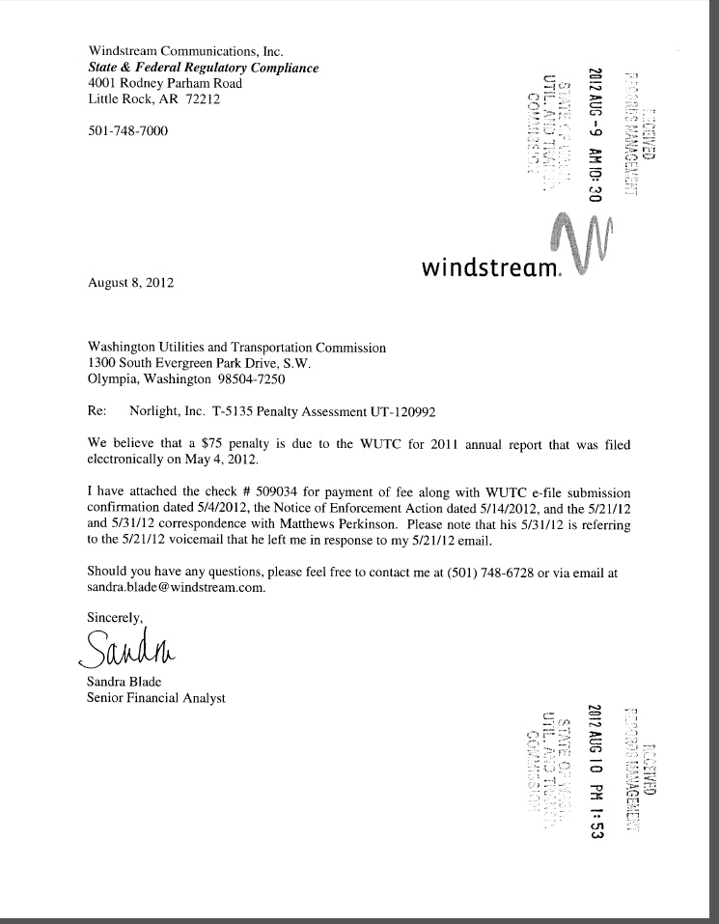
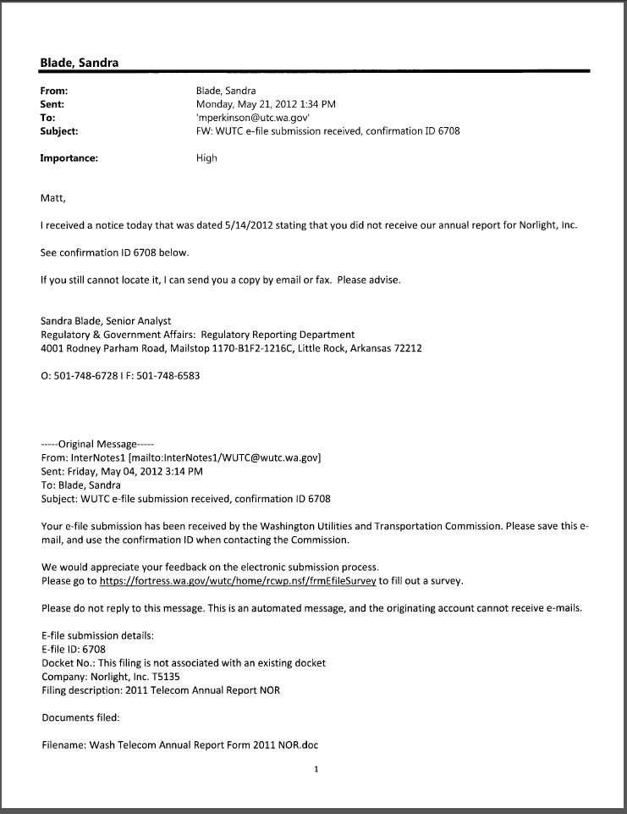
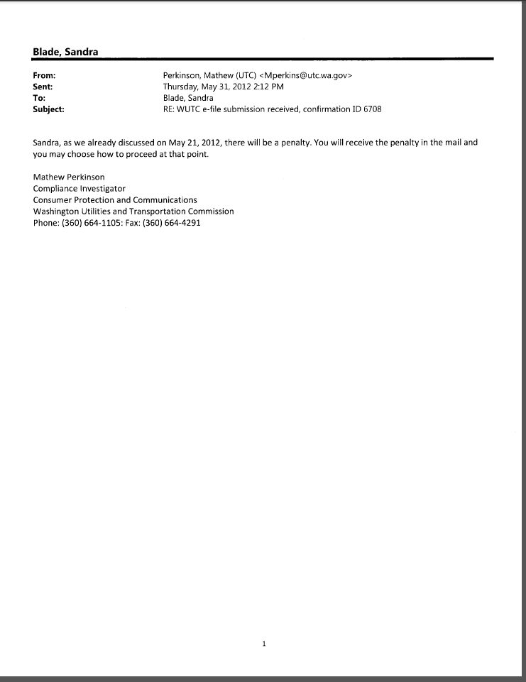
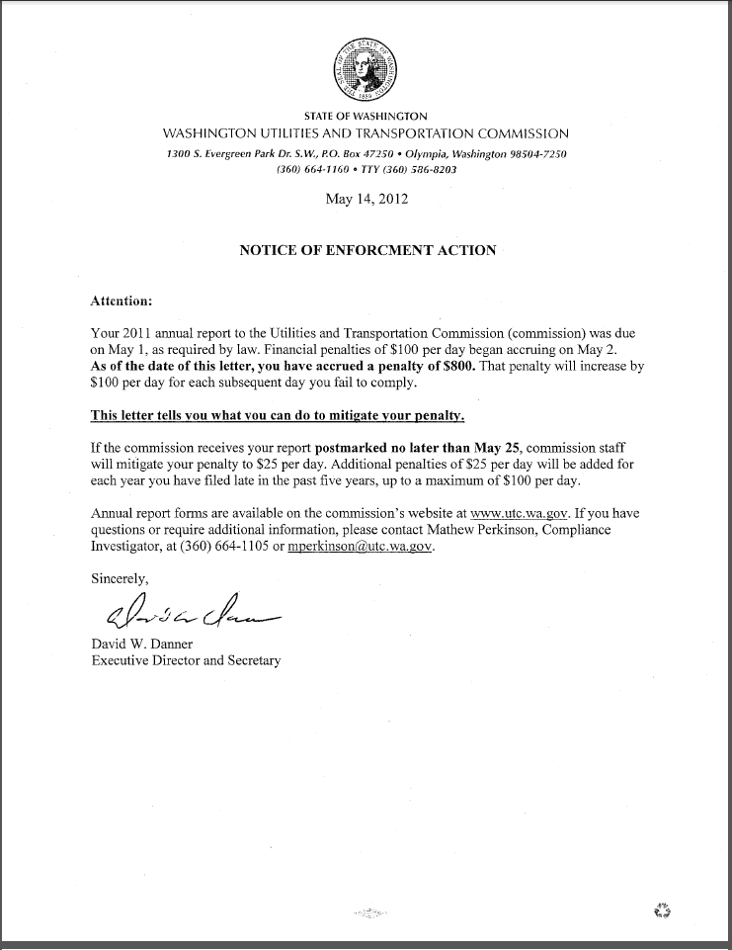
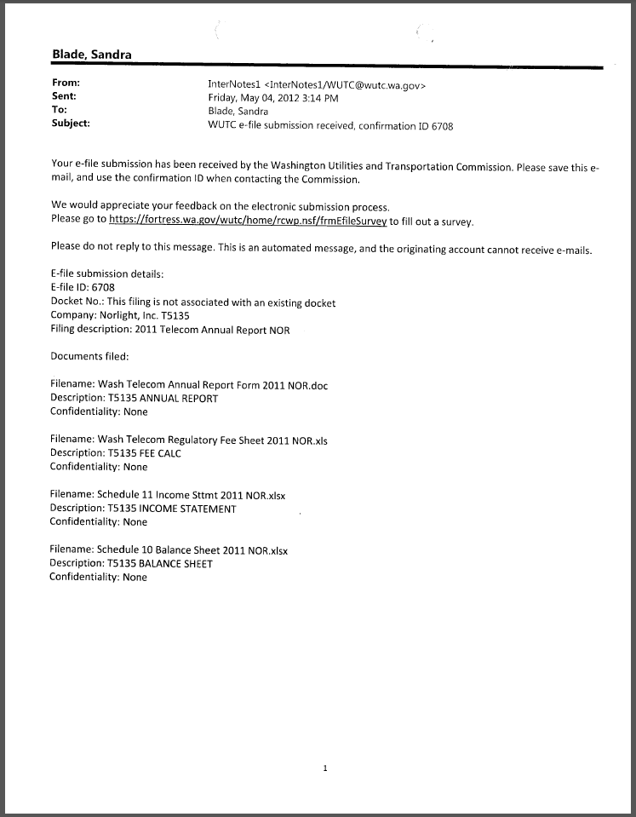

Attachment B

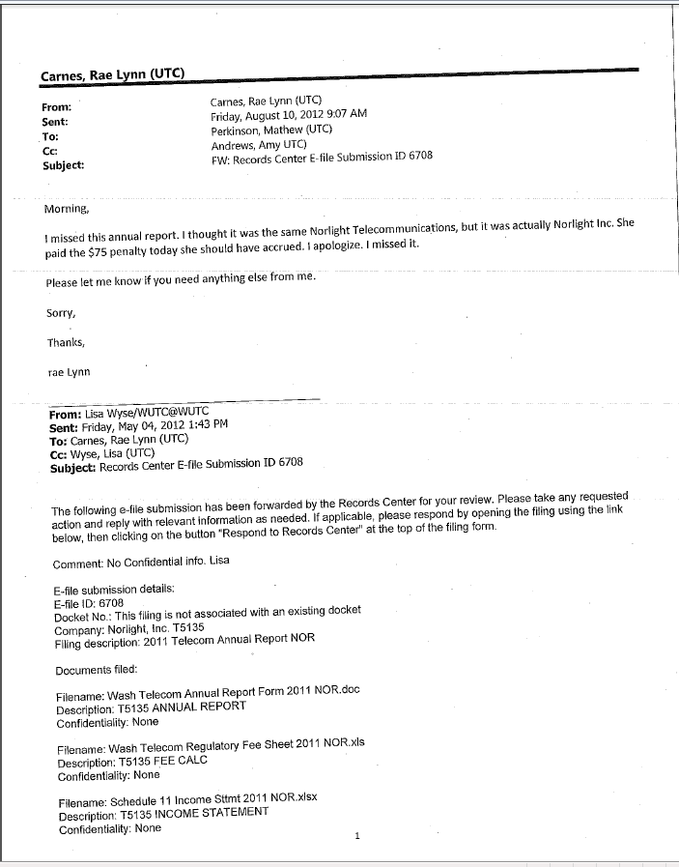

See attachment A for a copy of Norlight, Inc.’s Mitigation Request.

