August 22, 2011

### **VIA: Electronic Filing**

David Danner, Executive Director and Secretary

Washington Utilities & Transportation Commission

1300 S. Evergreen Park Drive S. W.

P.O. Box 47250

Olympia, Washington 98504-7250

RE: Avista’s 2010 Natural Gas Meter Measurement Performance Report

Dear Mr. Danner:

Attached for filing, is a copy of Avista Utilities “2010 Natural Gas Meter Measurement Performance Report” in compliance with WAC 480-90-353. An original copy is being provided via overnight mail.

If you have any questions regarding this filing, please contact David Howell at 509-495-8719.

Sincerely,

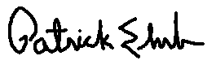

Patrick Ehrbar

Manager, Rates & Tariffs

Ph: 509-495-8620

[pat.ehrbar@avistacorp.com](mailto:pat.ehrbar@avistacorp.com)

cc: Deborah Reynolds

Attachment