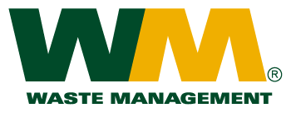

July 15, 2010

Washington Utilities and Transportation Commission

Chandler Plaza Building

1300 S. Evergreen Park Drive SW

P.O. Box 47250

Olympia, WA. 98504-7250

Dear Sirs:

Subject: Waste Management of Spokane, a division of Waste Management of Washington, Inc. (G-237); Tariff #16

Enclosed are revised tariff pages 2 and 36 for the above-referenced tariff. The purpose of this filing is to remove the 15, 25 and 27-yard drop box rates from the tariff, as these container sizes are not available to our customers. We currently do not have any customers who either have or have requested these container sizes.

If you have any questions or need additional information, please contact me at (425) 814-7840.

Very truly yours,

Michael A. Weinstein

Senior Pricing Manager, Pacific Northwest Market Area

cc: Marco Gonzales

Ken Gimpel