January 29, 2013

**FILED ELECTRONICALLY VIA WEB PORTAL**

Mr. David W. Danner

Executive Director & Secretary

Washington Utilities and Transportation Commission

Post Office Box 47250

1300 S. Evergreen Park Dr. SW

Olympia, Washington 98504-7250

**Subject: Docket UT-133002, 2013 Lifeline ETCs’ Annual Filings**

**Filing of Yakima MSA L.P. d/b/a US Cellular**

Dear Mr. Danner:

Pursuant to 47 C.F.R. § 54.416(b), enclosed for filing is the annual Form 555 for Yakima MSA L.P. d/b/a US Cellular.

If you have any questions please contact the undersigned.

Very truly yours,  
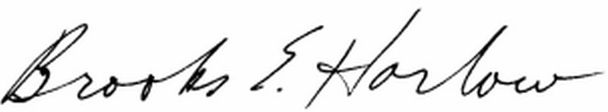  
Brooks E. Harlow, P.C.

CC via email:  
Ms. Jing Liu  
Ms. Stephanie Cassioppi

Mr. Steven Chernoff