July 3, 2014

Steven V. King, Executive Director and Secretary
Utilities and Transportation Commission
1300 S. Evergreen Park Dr. SW
P.O. Box 47250
Olympia, WA 98504-7250

RE: Washington Utilities and Transportation Commission v. Palouse Touring Company, LLC

Commission Staff’s Response to Application for Mitigation of Penalties TE-141072

Dear Mr. King:

On May 27, 2014, the Utilities and Transportation Commission issued a $1,000 Penalty Assessment in Docket TE-141072 against Palouse Touring Company, LLC for 10 violations of Washington Administrative Code (WAC) 480-30-071, which requires charter and excursion carriers to furnish annual reports to the commission no later than May 1 each year.¹

On June 19, 2014, Palouse Touring Company, LLC wrote the commission requesting mitigation of penalties (Mitigation Request).² In its Mitigation Request, Palouse Touring Company, LLC does not dispute that the violation occurred. The company provided the status as a new company in 2013 and a desire to report the data required accurately as the reasons for the late filing. The company also provided several internal accounting process changes to avoid future fines or violations.

It is the company’s responsibility to ensure that the regulatory fee is paid and the annual report is filed by the May 1 deadline. On February 28, 2014, Annual Report packets were mailed to all regulated charter and excursion companies. The instructions for annual report completion page of the annual report informed the regulated company that it must complete the annual report form, pay the regulatory fees, and return the materials by May 1, 2014, to avoid enforcement action.

On June 4, 2014, Palouse Touring Company, LLC filed the 2013 annual report and timely paid the required regulatory fees on November 27, 2013. The company has been active since September 19, 2013. No previous violations of WAC 480-30-071 are on commission record.
UTC Annual Reports
July 1, 2014
Page 2

The UTC also recently adopted new rules requiring the annual report to be filed by May 1 while the regulatory fees remained due on December 31. Despite the commission communication regarding these filing changes to all regulated charter and excursion companies, and the company’s good faith efforts to improve internal processed, commission staff supports the company’s request for mitigation. Staff recommends a reduced penalty assessment of $200.

If you have any questions regarding this recommendation, please contact Amy Andrews, Regulatory Analyst, at (360) 664-1157, or aandrews@utc.wa.gov.

Sincerely,

Sondra Walsh, Director
Administrative Services

ATTACHMENT A
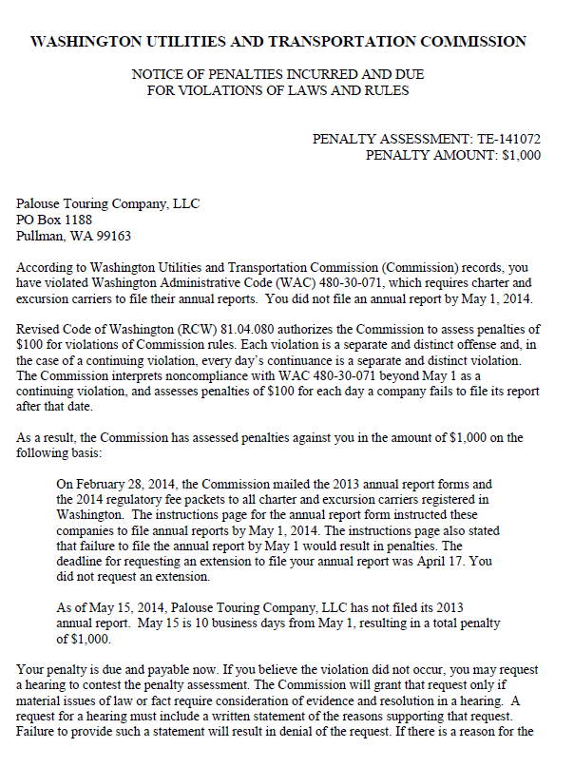

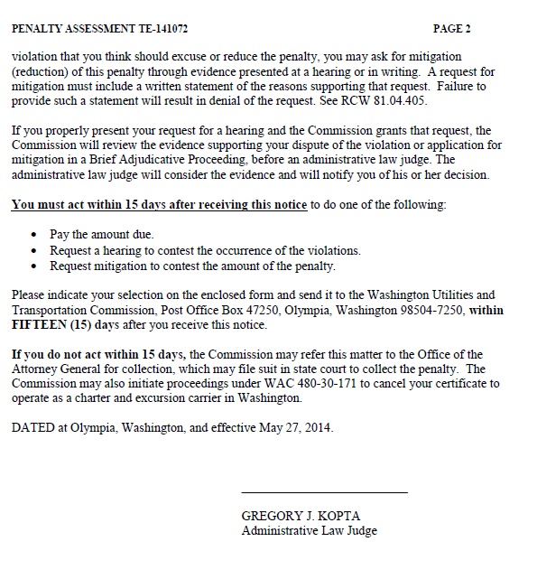

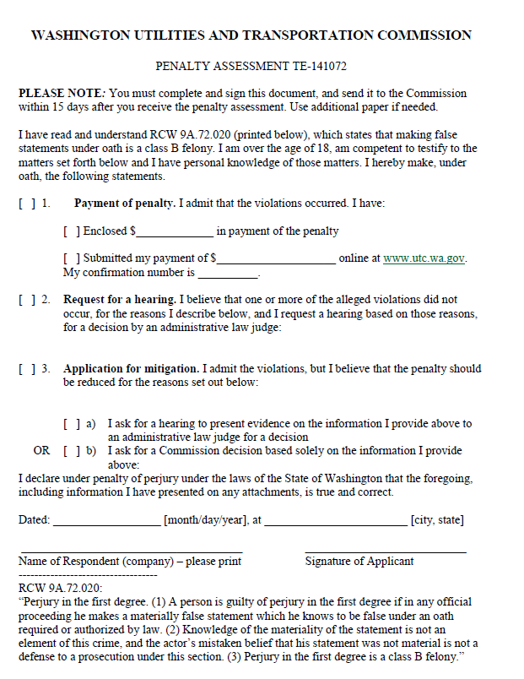

ATTACHMENT B
