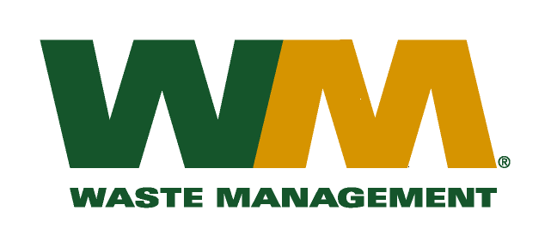

February 17, 2015

Washington Utilities and Transportation Commission

Chandler Plaza Building

1300 S. Evergreen Park Drive SW

P.O. Box 47250

Olympia, WA. 98504-7250

Subject: Waste Management of Spokane, a division of Waste Management of Washington, Inc. (G-237); Tariff No. 18 TG-143889

Enclosed herein, you will find revised replacement pages 16, 17, 22, 23, 24, 26, 28, 29, 31, 34, 35, 36, 37 and 38 for the above referenced docket. These pages are being replaced in concurrence with WUTC staff recommendations. Please do not re-docket.

If you have any questions or need additional information, please contact me at:

Address: 720 4th Avenue, Suite 400, Kirkland, WA 98033

Telephone /Fax #: (425) 814-7840 / (425) 814-7866

e-mail: mweinstein@wm.com

Respectfully,

Michael A. Weinstein

Senior Pricing Manager, Pacific Northwest Market Area