Whidbey Telephone – Year 1 – Funds distributed in 2014 – Report use of funds by July 1, 2015 – Docket UT-143041
The Company undertook projects in 2014 filed with FCC Form 481 filed with the Commission on August 1, 2014 in Docket No. UT-143041.
Network Improvements/Upgrades – Voice Services – For Calendar Year 2014
Project Description (Specific proposed improvements and/or upgrades) | Estimated Start Date | Estimated Completion Date | Service Area Name | Estimated Population
Install new BLCs at the following locations:  - Useless Bay  - Sea Lawn  - Bradshaw  - Windmill  - Sandy Point  - Mutiny Bay | 01/01/2014 | 12/31/2014 | South Whidbey | 3,076
Migrate ADSL Blades to VDSL | 01/01/2014 | 12/31/2014 | South Whidbey  Point Roberts | 17,252
MetaSwitch Upgrade | 01/01/2014 | 12/31/2014 | South Whidbey  Point Roberts | 17,252
Increase capacity of access transport network – South Whidbey ring upgrade | 01/01/2014 | 12/31/2014 | South Whidbey | 15,938
Additional Fiber deployment for access transport network | 01/01/2014 | 06/30/2014 | South Whidbey | 15,938
Maintain/retire/replace existing end-of-life infrastructure hardware and software | 01/01/2014 | 12/31/2014 | South Whidbey  Point Roberts | 17,252

Network Improvements/Upgrades – Broadband Services – For Calendar Year 2014
Project Description (Specific proposed improvements and/or upgrades) | Estimated Start Date | Estimated Completion Date | Service Area Name | Estimated Population
Install new BLCs at the following locations:  - Useless Bay  - Sea Lawn  - Bradshaw  - Windmill  - Sandy Point  - Mutiny Bay | 01/01/2014 | 12/31/2014 | South Whidbey | 3,076
Migrate ADSL Blades to VDSL | 01/01/2014 | 12/31/2014 | South Whidbey  Point Roberts | 17,252
Increase capacity of access transport network – South Whidbey ring upgrade | 01/01/2014 | 12/31/2014 | South Whidbey | 15,938
Additional Fiber deployment for access transport network | 01/01/2014 | 06/30/2014 | South Whidbey | 15,938
Maintain/retire/replace existing end-of-life infrastructure hardware and software | 01/01/2014 | 12/31/2014 | South Whidbey  Point Roberts | 17,252
The funds received from the Program can be viewed as contributing to the Company’s ability to perform those projects, including, without limitation, the repayment of loan funds.
Use of Support - WAC 480-123-130(1)(b) – Additional Information
For the calendar year 2014, the Company’s related gross capital expenditures and operating expenses paid, in whole or in part, with support from federal and state sources were $1,833,307 and $14,547,110 respectively. With regards to capital expenditures, of the total, $1,101,844 was used for the deployment of new Broadband Loop Carrier equipment (BLC) which benefit both voice and broadband services; $194,520 was used for fiber deployment: $53,932 was used for network improvements; and $483,000 was used for various projects designed to improve the capacity, coverage and quality of voice and broadband services throughout our service area.
Whidbey Telephone – Year 2 – Funds distributed in 2015 – Report use of funds by July 1, 2016 – Docket UT-151584
The Company undertook projects in 2015 filed with FCC Form 481 filed with the Commission on August 1, 2014 in Docket No. UT-143041:
Network Improvements/Upgrades – Voice Services – For Calendar Year 2015
Project Description (Specific proposed improvements and/or upgrades) | Estimated Start Date | Completion Date | Service Area Name | Estimated Population
Install new BLCs at the following locations:  - Baby Island  - Humphrey Road  - Lagoon Point  - Lake View Terrace | 01/01/2015 | Partially Completed  12/31/2015 | South Whidbey | 1,578
Migrate ADSL Blades to VDSL | 01/01/2015 | 12/31/2015 | South Whidbey  Point Roberts | 17,252
Upgrade Core Network Transport Capacity | 01/01/2015 | 12/31/2015 | South Whidbey  Point Roberts | 17,252
MetaSwitch Upgrade | 01/01/2015 | 12/31/2015 | South Whidbey  Point Roberts | 17,252
Increase capacity of access transport network – South Whidbey ring upgrade | 01/01/2015 | 12/31/2015 | South Whidbey | 15,938
Additional Fiber deployment for access transport network | 01/01/2015 | 06/30/2015 | South Whidbey | 15,938
IPV6 Upgrade | 01/01/2015 | Not Completed | South Whidbey  Point Roberts | 17,252
Maintain/retire/replace existing end-of-life infrastructure hardware and software | 01/01/2015 | 12/31/2015 | South Whidbey  Point Roberts | 17,252

Network Improvements/Upgrades – Broadband Services – For Calendar Year 2015
Project Description (Specific proposed improvements and/or upgrades) | Estimated Start Date | Estimated Completion Date | Service Area Name | Estimated Population
Install new BLCs at the following locations:  - Baby Island  - Humphrey Road  - Lagoon Point  - Lake View Terrace | 01/01/2015 | Partially Completed 12/31/2015 | South Whidbey | 1,578
Migrate ADSL Blades to VDSL | 01/01/2015 | 12/31/2015 | South Whidbey  Point Roberts | 17,252
Upgrade Core Network Transport Capacity | 01/01/2015 | 12/31/2015 | South Whidbey  Point Roberts | 17,252
Increase capacity of access transport network – South Whidbey ring upgrade | 01/01/2015 | 12/31/2015 | South Whidbey | 15,938
Additional Fiber deployment for access transport network | 01/01/2015 | 06/30/2015 | South Whidbey | 15,938
IPV6 Upgrade | 01/01/2015 | Not Completed | South Whidbey  Point Roberts | 17,252
Maintain/retire/replace existing end-of-life infrastructure hardware and software | 01/01/2015 | 12/31/2015 | South Whidbey  Point Roberts | 17,252
In January 2015, the Company received $339,868.00 from the universal service communications program for the fiscal year ending June 30, 2015 representing the reduction in support from the CAF ICC Program. For the calendar year 2015, the Company’s related gross capital expenditures and operating expenses paid, in whole or in part, with support from federal and state sources were $1,657,975 and $11,994,230 respectively. With regards to capital expenditures, of the total, over $250K was used in the further deployment of new Broadband Loop Carrier (BLC) equipment, approximately $150K in further fiber deployment, $85K in further deployment of VDSL technology, and approximately $400K in network improvements, all of which benefit both voice and broadband services. The Company also invested $50K in the upgrade of MetaSwitch through the deployment of MetaSwitch Accession which benefits voice services directly. In addition, the Company invested approximately $450K in projects relating to telecommunications drop work, and infrastructure improvements, and $200K in replacement/upgrade of end-of-life infrastructure hardware and software. All projects are described further below.
All of the capital projects are designed to improve the quality, reliability and capacity of existing services, and to improve the cost effectiveness of providing those services. In particular, the Company completed a number of projects deploying fiber deeper into our network through the continued completion of BLCs (Broadband Loop Carriers). These BLCs enhance all existing services by providing greater reliability, reduced operating costs and allows us to offer faster broadband speeds to our customers. The Company also completed significant work regarding network redundancy that greatly reduces the potential for service interruptions and provides greater business continuity in the event of a catastrophe. Installing the Fujitsu FW-9500 shelves and other hardware, improved our interconnections outside of our service area which improves our ability to monitor and direct traffic in a more efficient and cost effective manner. The Company also deployed Metaswitch Accession, which enhances our existing voice services by enabling soft client access for customers with the existing service. The Company also continued to address lifecycle issues with both hardware and software, such as the Windows Server 2013 upgrade, which again insures the quality and performance of our existing infrastructure. The Company continued the deployment of VDSL technology, which improves capacity on our existing copper plant, the quality of all services, and allows the Company to offer higher broadband speeds on existing infrastructure. The funds received from the universal service communications program can be viewed as contributing to the Company's ability to perform those projects, including, without limitation, the repayment of loan funds.
The Company undertook projects in 2016 filed with FCC Form 481 filed with the Commission on August 1, 2014 in Docket No. UT-143041:
Network Improvements/Upgrades – Voice Services – For Calendar Year 2016
Project Description (Specific proposed improvements and/or upgrades) | Estimated Start Date | Estimated Completion Date | Service Area Name | Estimated Population
Install new BLCs at the following locations:  - Goss Lake  - Beverly Beach | 01/01/2016 | 06/30/2016 | South Whidbey | 658
Migrate ADSL Blades to VDSL | 01/01/2016 | 12/31/2016 | South Whidbey  Point Roberts | 17,252
MetaSwitch Upgrade | 01/01/2016 | 12/31/2016 | South Whidbey  Point Roberts | 17,252
Upgrade Core Network Transport Capacity | 01/01/2016 | 12/31/2016 | South Whidbey  Point Roberts | 17,252
Increase capacity of access transport network – South Whidbey ring upgrade | 01/01/2016 | 12/31/2016 | South Whidbey | 15,938
Additional Fiber deployment for access transport network | 01/01/2016 | 06/30/2016 | South Whidbey | 15,938
IPV6 Upgrade | 01/01/2016 | 12/31/2016 | South Whidbey  Point Roberts | 17,252
Maintain/retire/replace existing end-of-life infrastructure hardware and software | 01/01/2016 | 12/31/2016 | South Whidbey  Point Roberts | 17,252

Network Improvements/Upgrades – Broadband Services – For Calendar Year 2016
Project Description (Specific proposed improvements and/or upgrades) | Estimated Start Date | Estimated Completion Date | Service Area Name | Estimated Population
Install new BLCs at the following locations:  - Goss Lake  - Beverly Beach | 01/01/2016 | 06/30/2016 | South Whidbey  Point Roberts | 658
Migrate ADSL Blades to VDSL | 01/01/2016 | 12/31/2016 | South Whidbey  Point Roberts | 17,252
Upgrade Core Network Transport Capacity | 01/01/2016 | 12/31/2016 | South Whidbey  Point Roberts | 17,252
Increase capacity of access transport network – South Whidbey ring upgrade | 01/01/2016 | 12/31/2016 | South Whidbey | 15,938
Additional Fiber deployment for access transport network | 01/01/2016 | 06/30/2016 | South Whidbey | 15,938
IPV6 Upgrade | 01/01/2016 | 12/31/2016 | South Whidbey  Point Roberts | 17,252
Maintain/retire/replace existing end-of-life infrastructure hardware and software | 01/01/2016 | 12/31/2016 | South Whidbey  Point Roberts | 17,252
In December 2015, the Company received $748,392.00 from the universal service communications program for the fiscal year ending June 30, 2016 which represents monies that the Company formerly received through the WECA pooling process and the reduction of support under the FCC’s CAF ICC Program. Through the first four months of 2016, the company has spent approximately $434K in capital expenditures and $3,962K in operating expenses. With regards to the capital expenditure, of the total, approximately $167K was spent in fiber deployment, $29K in VDSL expansion, $136K in telecommunications drops and infrastructure improvements, and $100K in expenditures relating to the replacement/upgrade of end-of-life infrastructure and software.
During the first six months of 2016 the Company has undertaken a strategic shift to continue further deployment of fiber within our core network, and by deploying fiber directly to homes and businesses. The Company completed deployment of a BLC in a key area, and began work on an FTTH/FTTB (Fiber to the Home/Fiber to the Business) project in one of our key municipal areas, the City of Langley. The Company has continued to deploy VDSL technology as mentioned previously, and has continued effectively replacing end-of-lifecycle hardware and software as required. The Company continues its focus on improving the quality, reliability and capacity of our services, and to provide our customers with service levels and products that they desire, always with the mindset to do so in the most cost effective manner possible. In the second half of 2016 the Company plans to continue to expand the FTTH/FTTB project through the further strategic deployment of fiber in key sectors of our service area. In addition, further deployment of VDSL technology is planned.
Whidbey Telephone – Year 3 – Funds distributed in 2016 – Reported use of funds by July 1, 2017 – Docket UT-160971
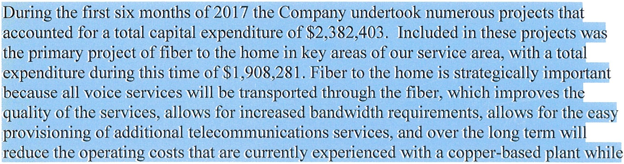
In December 2016, the Company received $845,613 from the universal service communications program for the fiscal year ending June 30, 2017 which represents monies that the Company formerly received through the WECA pooling process and the reduction of support under the FCC’s CAF ICC Program.

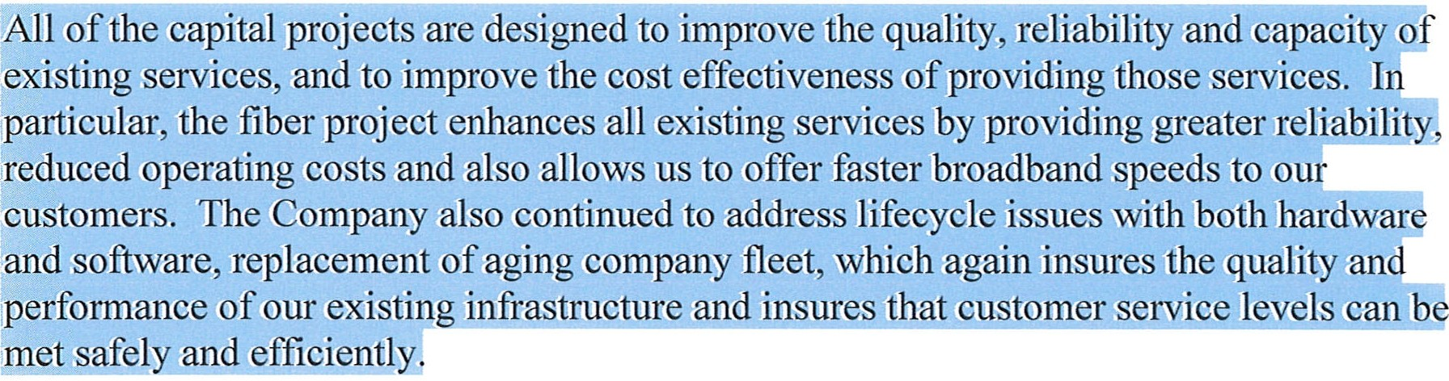
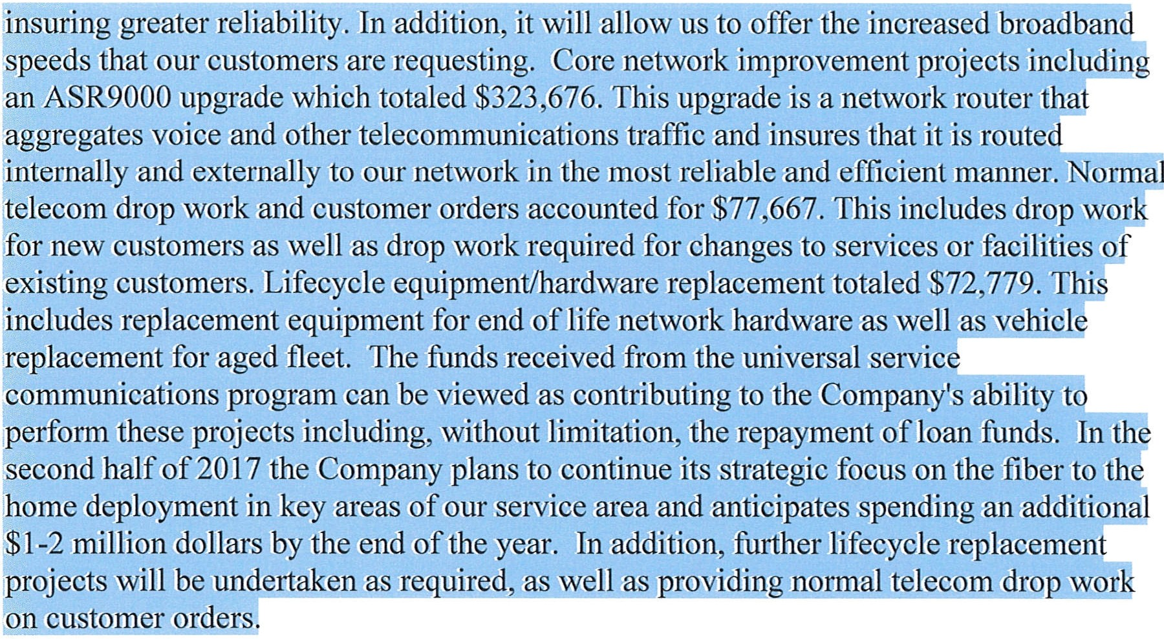
Whidbey Telephone – Year 4 – Funds distributed in 2017 – Reported use of funds by July 1, 2018 – Docket UT-170860
In December 2017, the Company received $937,632.00 from the universal communications services program for the fiscal year ending June 30, 2018.
During the first six months of 2018, the Company undertook several projects. The fiber to the home project continued into 2018 with capital spending of $224,828. Fiber to the home is strategically important because all voice services will be transported through the fiber, which improves the quality of the services, allows for increased bandwidth requirements, allows for the easy provisioning of additional telecommunication services, and over the long term will reduce the operating costs that are currently experienced with a copper-based plant while insuring greater reliability. The Company has also continued the migration of ADSL blades to VDSL blades according to schedule, spending $49,642 in 2018. The deployment of VDSL technology improves capacity on our existing copper plant, the quality of all services, and allows the Company to offer higher broadband speeds on existing infrastructure where fiber would be impractical to deploy.
With the extensive fiber build out in 2017 and 2018, the company has focused on the normal telecom drop work and customer orders which accounted for $62,720. This includes drop work for new customers as well as drop work for changes to services or facilities of existing customers. The Company had operating expenditures of $2,559,700 for the first half of 2018. These expenditures include material and labor expenses, and can be for a variety of purposes including, but not limited to, equipment repair and maintenance; service order fulfillment; customer service requests; capital expenditures; company equipment monitoring; equipment service/testing; technical support both at premise and remotely; and service calls. The funds received from the universal communications services program can be viewed as contributing to the Company's ability to perform those projects and expenditures, including, without limitation, the repayment of loan funds. In the second half of 2018 the Company plans on the continuing migration of ADSL blades to VDSL blades, lifecycle replacement projects will be undertaken as required, building out fiber to strategic areas at our Pt. Roberts, WA service area, as well as providing normal telecom drop work on customer orders.
All of the capital projects and services are designed to improve the quality, reliability and capacity of existing services, and to improve the cost effectiveness of providing those services.

