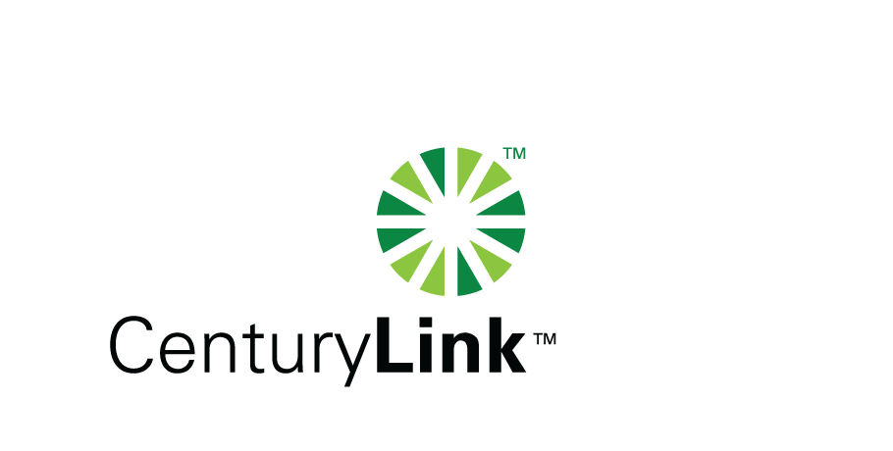

November 19, 2014

Steven V. King, Executive Director & Secretary

Washington Utilities & Transportation Commission

1300 S Evergreen Park Drive, SW

Olympia, Washington 98504-7250

Re: Revised Washington Quality of Service Report for CenturyTel, Docket No. UT-921192.

Dear Mr. King:

Please find attached the revised Washington Quality of Service Report for CenturyTel, Docket No. UT-921192 correction the repair commitment missed for the month of October 2014

If you should you have any questions, please contact Mark Reynolds at (206) 345-1568 or by e-mail at Mark.Reynolds3@Centurylink.com.

Sincerely,

Mark Reynolds

Enclosures: Installation/Repair Appointments