October 22, 2012

David W. Danner, Executive Director and Secretary

Washington Utilities and Transportation Commission

1300 S. Evergreen Park Dr. SW

P. O. Box 47250

Olympia, Washington 98504-7250

RE: *Washington Utilities and Transportation Commission v. Can’t Stop Moving, LLC*

Commission Staff’s Response to Application for Mitigation of Penalties

Docket TV-120918

Dear Mr. Danner:

On July 23, 2012, the Washington Utilities and Transportation Commission issued a $1,125 Mitigated Penalty Assessment in Docket TV-120918 against Can’t Stop Moving, LLC for 15 violations of Washington Administrative Code (WAC) 480-15-480, which requires permitted household goods companies to furnish annual reports to the commission no later than May 1 each year.

On August 13, 2012[1], Can’t Stop Moving, LLC wrote the commission requesting mitigation of penalties (Mitigation Request). In its Mitigation Request, Can’t Stop Moving, LLC does not dispute that the violation occurred. The company states, “We realize we made a mistake and sent in the report as soon as we received the late notice. We would appreciate any leniency that could be given, and we pledge to have paperwork filed and submitted on time in the future. Thank you for your consideration.”

It is the company’s responsibility to ensure that the regulatory fee and the annual report are filed by the May 1 deadline. On February 29, 2012[2], Annual Report forms and Regulatory Fee packets were mailed to all regulated permitted household goods companies. In addition to other information, the cover letter informed the regulated company it must complete the annual report form, pay any regulatory fees and return the material by May 1, 2012 to avoid enforcement action. On May 15, 2012[3], the commission mailed a letter to those companies that had not yet filed an annual report notifying them that, to date, they had incurred a penalty of $900. The letter went on to explain that companies who filed their annual reports no later than May 25, 2012, would receive mitigated penalties of $25 per day, with an additional $25 per day for each instance in the previous five years that the company received a penalty for filing a late report.

Can’t Stop Moving, LLC, filed its annual report on May 23, 2012, which is 15 business days past the deadline of May 1, 2012. The penalty was mitigated from $100 per day to $25 per day for a total of $375. Can’t Stop Moving, LLC. has held permanent household goods authority since October 2009 and received a penalty for failing to file annual reports by the deadline in 2010 and 2011. The prior penalties increase the current penalty by an additional $50 per day for a total of $750.

Based on the company’s delinquent annual report filing in the past, staff does not support mitigating the assessed penalty further and recommends the request be denied.

If you have questions regarding this recommendation, please contact Mathew Perkinson, Compliance Investigator, at (360) 664-1105 or at mperkinson@utc.wa.gov.

Sincerely,

Sharon Wallace, Assistant Director

Consumer Protection and Communications

**Attachment A**

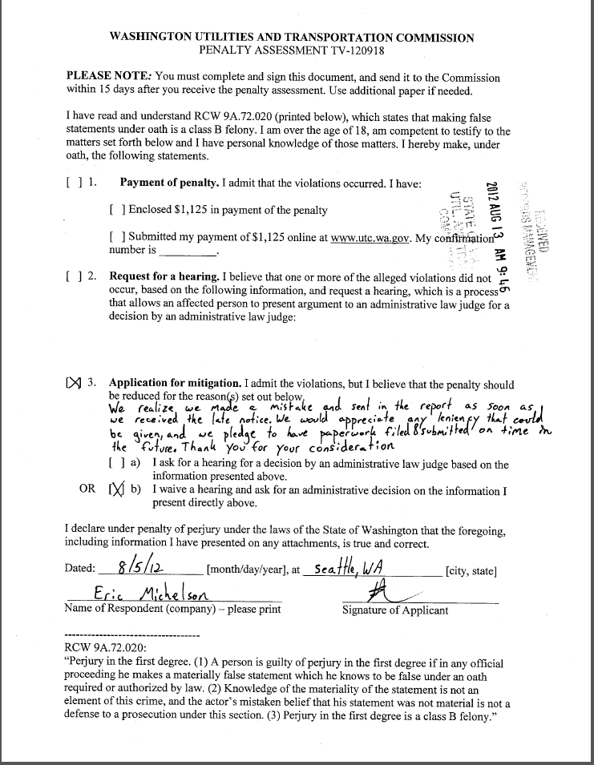

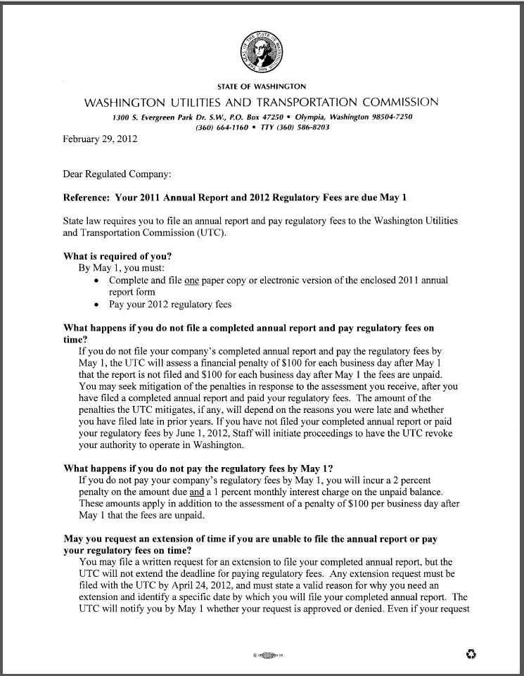**Attachment B**

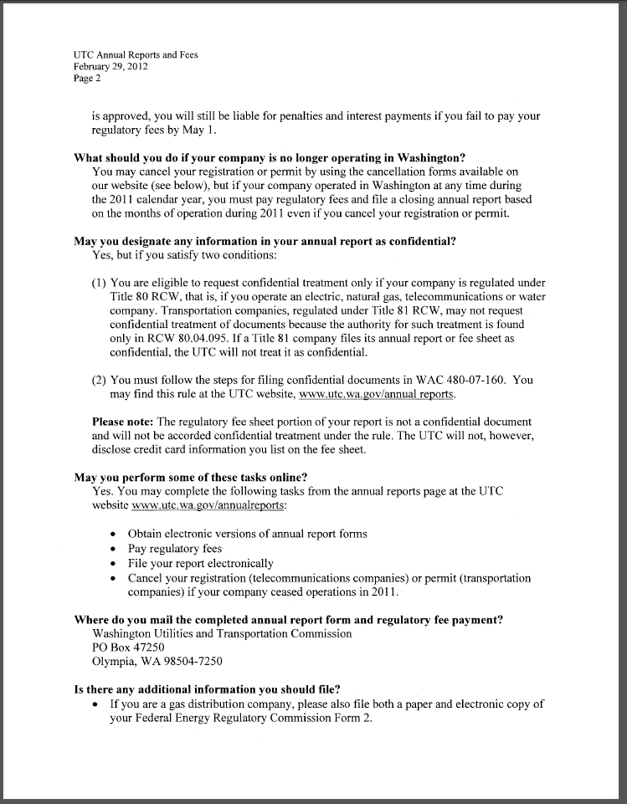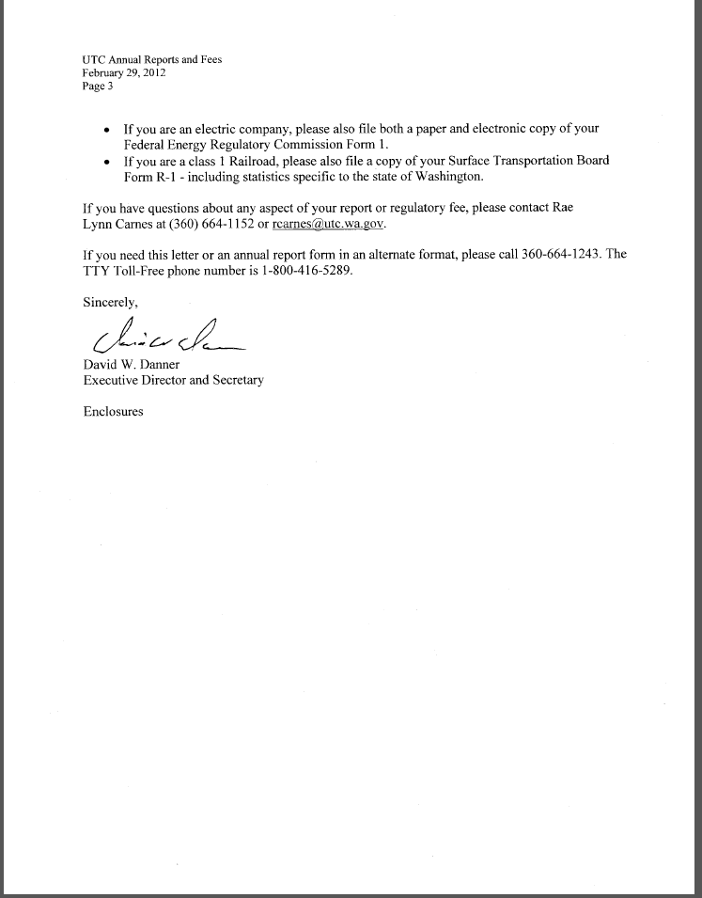

**Attachment C**

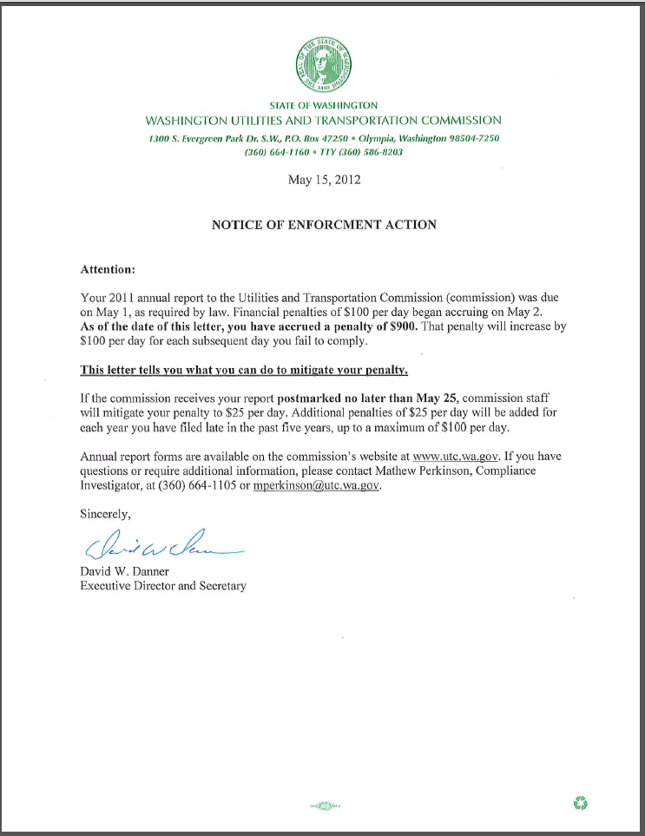

1. See attachment A for a copy of Can’t Stop Moving, LLC’s Mitigation Request.
2. See attachment B for a copy of the letter sent to all regulated companies on February 29, 212.
3. See attachment C for a copy of the enforcement letter sent to the company on May 15, 2012.