Steven King

Executive Director and Secretary

Washington Utilities and Transportation Commission

1300 S. Evergreen Park Dr. S.W.

Olympia WA 98504-7250

August 29th, 2016

Docket UT-160032

Re: WAC 480-123-130(1)(e) requiring all wireline communication providers that receive state USF program support to file copies of Form 477

Dear Mr. King:

Enclosed is a copy of our 477 as files with the FCC period ended 06/30/2016.

Sincerely,

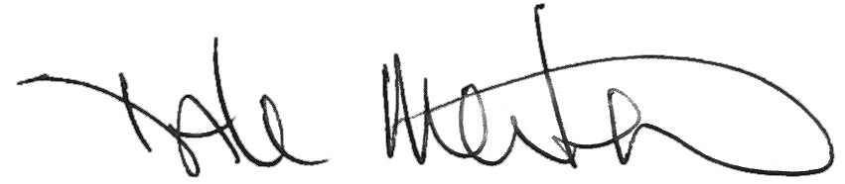

Dale Merten

C.O.O.

ToledoTel

306-864-2044

[dale@toledotel.com](mailto:dale@toledotel.com)

Enclosures