September 28, 2012

David W. Danner, Executive Director and Secretary
Washington Utilities and Transportation Commission
1300 S. Evergreen Park Dr. SW
P. O. Box 47250
Olympia, Washington 98504-7250

RE: Washington Utilities and Transportation Commission v. CoSpeed LLC.
Commission Staff’s Response to Request for Mitigation of Penalties
Docket UT-120966

Dear Mr. Danner:

On July 30, 2012, the Washington Utilities and Transportation Commission issued a $2,100 Penalty Assessment in Docket UT-120966 against CoSpeed LLC. (CoSpeed) for 21 violations of Washington Administrative Code (WAC) 480-120-382, which requires competitively classified telecommunications companies to furnish annual reports to the commission no later than May 1 each year.

It is the company’s responsibility to ensure that the regulatory fee and the annual report are filed by the May 1 deadline. On February 29, 2012, Annual Report forms and Regulatory Fee packets were mailed to all competitively classified telecommunications companies. In addition to other information, the cover letter informed the regulated company it must complete the annual report form, pay any regulatory fees and return the material by May 1, 2012, to avoid enforcement action. The letter also stated a company may file a written request for an extension, however the request must be filed with the commission by April 24, 2012, and must state a valid reason for why the extension is needed, along with the date the report will be filed. The company did not file a request for an extension. The letter instructed the companies, if they no longer operated in Washington, to go to the commission’s website and cancel its registration or permit, however if the company operated in Washington at any time during the 2011 calendar year, it must pay regulatory fees and file a closing annual report based on the months of operation during 2011, even if it cancels its registration or permit. The company did not cancel its registration and it did not file a closing annual report.

On May 14, 2012, the commission mailed a letter to those companies that had not yet filed an

annual report notifying them that, to date, they had incurred a penalty of $800. The letter went on to explain that companies who filed their annual reports no later than May 25, 2012, would receive mitigated penalties of $25 per day, with an additional $25 per day for each instance in the previous five years that the company received a penalty for filing a late report. The company had substantial time and sufficient notice to file its annual report by the May 1 deadline.

On May 22, 2012, CoSpeed called the commission, requesting the $2,100 penalty assessment be waived because the company is no longer operating in Washington state. Commission staff informed CoSpeed it would remove the penalty if the company did, indeed, cease operations during the reporting year in question, but failed to cancel its registration.

According to the Washington Secretary of State Website, CoSpeed became inactive on October 6, 2011.

Despite CoSpeed failing to pay regulatory fees and file a closing annual report, staff recommends waiving any and all penalties related to CoSpeed’s 2011 annual report. The commission’s policy in this scenario is to not enforce the annual report and regulatory fee requirements even though it has the authority to do so.

If you have questions regarding this recommendation, please contact Mathew Perkinson, Compliance Investigator, at (360) 664-1105, or at mperkinson@utc.wa.gov.

Sincerely,

Sharon Wallace, Assistant Director
Consumer Protection and Communications

Attachment A
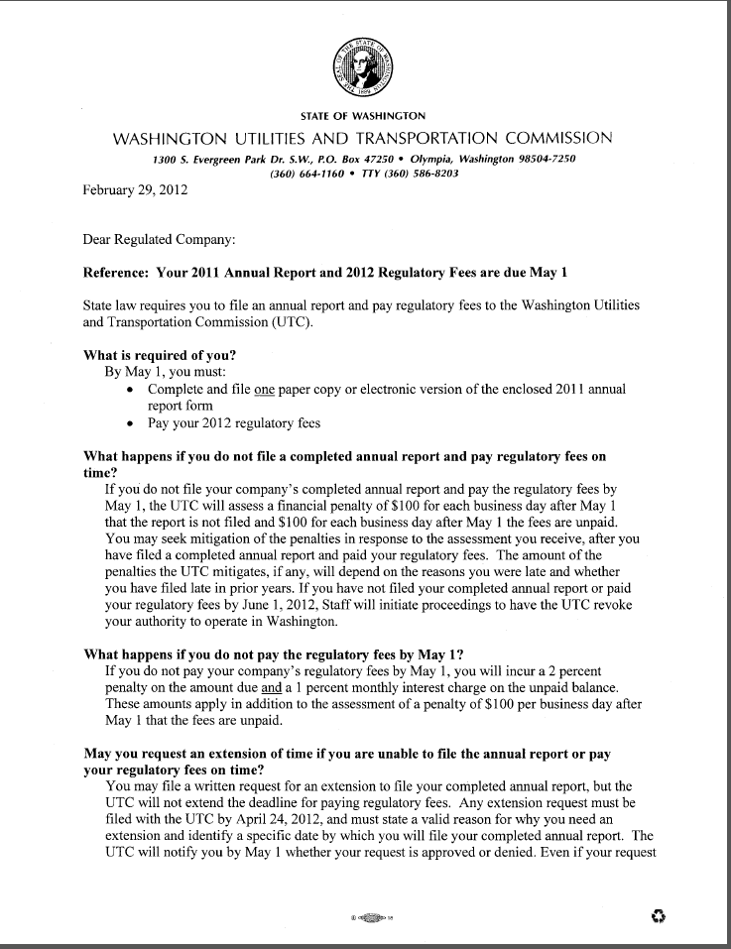
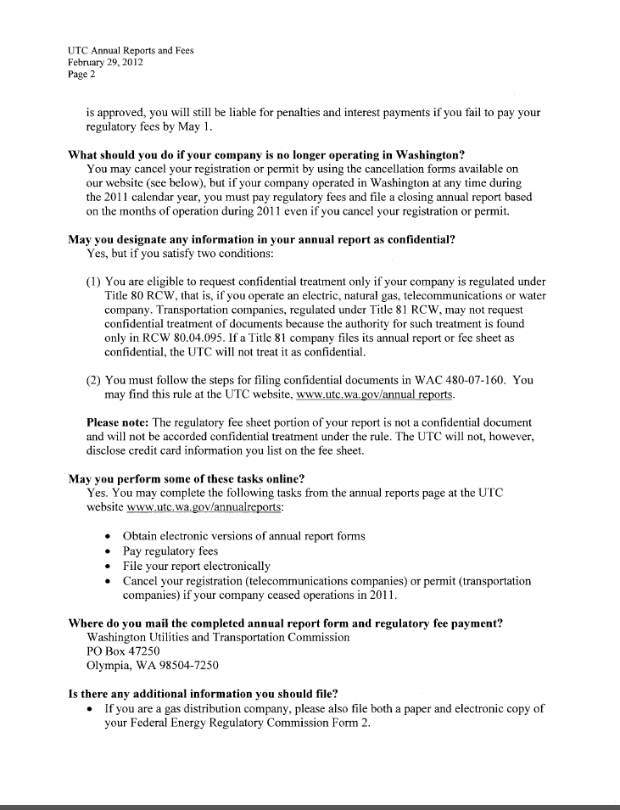
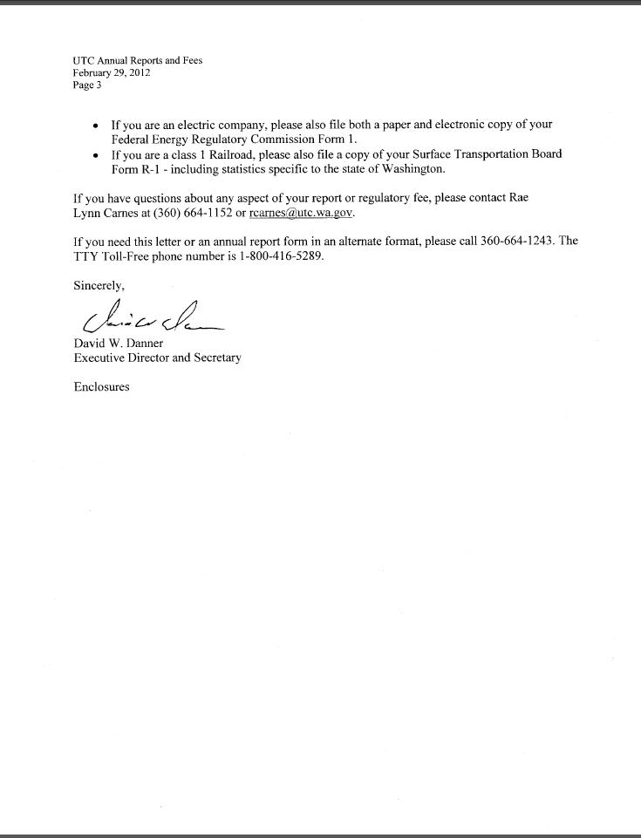
Attachment B
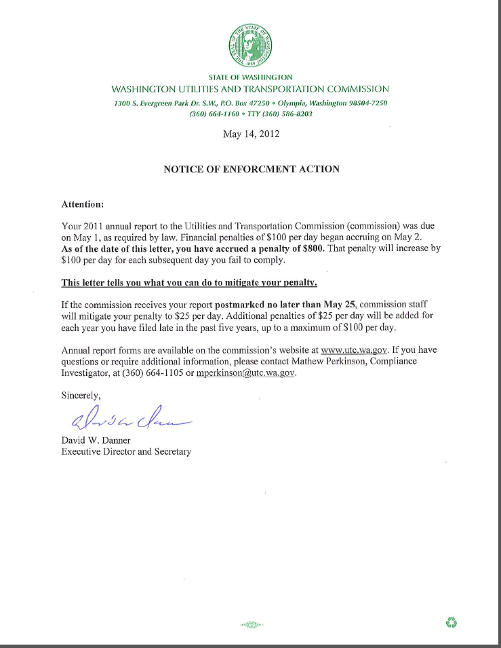

See attachment A for a copy of the letter sent to all regulated companies on February 29, 2012.
See attachment B for a copy of the enforcement letter sent to the company on May 14, 2012.

