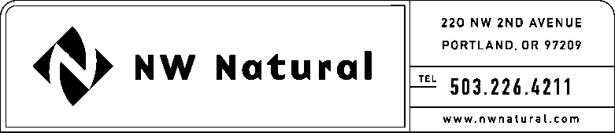

# GAIL A. HAMMER

Tariffs and Regulatory Compliance

Tel: 503.226.4211, ext. 5865

Fax: 503.721.2516

email: gail.hammer@nwnatural.com

June 16, 2016

**VIA ELECTRONIC FILING**

Steven King, Executive Director and Secretary

Washington Utilities and Transportation Commission

1300 S. Evergreen Park Drive, S.W.

P.O. Box 47250

Olympia, Washington 98504-7250

**RE:** **NW Natural’s Washington Pipeline Replacement Plan**

**PG - 160754 - related to Docket UG-120715 and PG-131840**

Northwest Natural Gas Company, dba NW Natural (“NW Natural” or the “Company”) hereby submits an original and two copies of its Modified Washington Pipeline Replacement Plan (Modified Plan). This filing is pursuant to the Commission’s Order 02 in PG-131840.

The Plan was initially filed May 27, 2016. Upon Staff’s request, the Company is now filing a Modified Plan that includes additional language on Polyoxymethylene (Celcon) caps.

If you have any questions, please contact me at (503) 226-4211, extension 5865.

Sincerely,

*/s/ Gail A. Hammer*

Gail A. Hammer

Rates & Regulatory Affairs

Enclosures