Agenda Date: May 19, 2016
Item Number: D1

Docket: UT-143787
Company: Neustar, Inc., The North American Numbering Plan Administrator (NANPA)

Staff: Rebecca Beaton, Infrastructure Analyst
Tim Zawislak, Regulatory Analyst
Jing Roth, Assistant Director – Telecommunications

Recommendation

The Utilities and Transportation Commission (commission) should enter an order:

- Directing all industry providers to implement mandatory ten-digit local dialing in western Washington number plan areas 206, 253, 360, and 425 by September 30, 2017, and in addition, approving an all services overlay of the 564 area code for new numbers as western Washington area codes exhaust, starting with area code 360 no later than March 31, 2018, and expanding to other area codes as they exhaust their existing number inventories over time.

- Requiring all western Washington industry providers to initiate a comprehensive education program introducing and explaining the need for mandatory 10-digit dialing, and begin network preparation and all other necessary implementation within 45 days from the date of the commission’s order.

- Directing commission staff to participate in the technical deployment, customer education, community involvement, media releases, and public workshops to ensure the implementation of this plan. The North American Numbering Plan Administrator (NANPA), Neustar, Inc., should coordinate with industry providers to develop milestones and file quarterly reports to the commission on the last day of each calendar quarter until full completion, beginning September 30, 2016, and ending not later than March 31, 2018.

Background

The commission previously determined in Docket UT-991535 that a single area code would overlay the existing western Washington 206, 253, 360, and 425 number plan area (NPA or area code). The commission thus approved a new area code that would eventually serve all western Washington geographic areas but it did not establish a firm implementation schedule. The western Washington area code overlay and mandatory ten-digit local dialing were later postponed, and then suspended, due to the success of state and national number conservation efforts. Given the suspension, NANPA reserved the 564 NPA for future use in western Washington.

NANPA initially notified the commission in December 2014 that the 360 NPA was within 36 months of forecasted exhaust, which was then expected to occur in the third quarter of 2017. In September 2015 NANPA informed the commission that the 360 NPA exhaust projection was being revised to first quarter 2019, giving an additional eighteen months of life to the 360 area code. On March 25, 2016, however, the NANPA notified the commission that the 360 NPA was within 24 months of its forecasted exhaust, which is now expected to occur during the first quarter of 2018.

Notice and Comments Received

On April 14, 2016, the commission gave notice that it would receive comments on a proposed plan addressing area code exhaust in western Washington’s 360 NPA, and scheduled a recessed open meeting on the topic. On May 6, 2016, the commission received written comments filed jointly by industry providers and one consumer. All comments indicate support of the area code relief plan. The industry providers propose a thirteen month schedule (Attachment 2) to allow an orderly implementation including, but not limited to: customer notifications, customer education, press releases, letters to industry, and directory publications, network transition notices, and recorded announcements.

Staff agrees with the industry proposed schedule for implementation and their comment that “the Commission found in Docket UT-991535 that it was in the public interest to use a single overlay for all of western Washington and that nothing has occurred in the intervening years to suggest that the commission should change its previous conclusion.” In its order in Docket UT-991535, the commission also determined that it was in the public interest to implement ten-digit dialing in all western Washington NPAs concurrently with the overlay of 564. This approach assures that all existing customers will retain their current area code and their current telephone number. NANPA expects the recommended 564 NPA overlay plan will be sufficient for 33 years.

Discussion

Overlay phase-in approach

The commission determined the need for an overlay and ten-digit dialing in all of western Washington NPAs in Docket UT-991535. Staff does not have any reason to propose a different recommendation at this time. The commission has flexibility to control the distribution of the 564 NPA numbers, and to require the use of existing numbers in each western Washington area code until forecasted to exhaust. Based on projections provided by Neustar, Inc., and the dispersed projection dates for other area code exhaustion, staff and industry providers support a phased-in implementation of the 564 NPA overlay across western Washington NPAs starting with the 360 NPA, which will reach exhaust sooner than the other area codes.

Implementation of mandatory ten-digit dialing

An area code overlay requires mandatory ten-digit local dialing. The prior commission order found ten-digit dialing is in the public interest by implementing a single and coordinated customer notification plan for all of western Washington. Staff agrees and recommends that ten-digit dialing be mandatory for all of western Washington immediately upon implementation of the first area code overlay of 360/564. This approach develops a consistent set of requirements across the region and minimizes dialing pattern confusion as cross-boundary area code calling is, and has been, very common. It also assures efficiency in terms of consumer education and network modifications. Uniform ten-digit dialing across all of western Washington would require these efforts to be undertaken only once instead of on multiple occasions as each NPA is overlaid.

Customers have readily adjusted to ten-digit dialing with all-services overlay numbering configurations in other regions. The communications industry has consistently recommended an overlay with ten-digit dialing to implement area code relief. The reasons cited for this recommendation include: the majority of industry providers calling plans require mandatory ten-digit dialing; most consumers have devices with functional capabilities to store numbers so manual dialing is being superseded by automated connections; networks accept number portability so numbers may be moved to another service provider, location, or type of service with few limitations on geography, service area, or device; and applications allow number resources to become less regionally distinct.

Conclusion

Commission staff recommends that the commission issues an order implementing an all-services area code overlay by the introduction of a fifth area code, 564 NPA, covering western Washington number plan areas 206, 253, 360, and 425, using a phased in approach , and uniform mandatory ten-digit dialing for all western Washington area codes. Commission staff recommends that the commission require all industry providers to initiate a comprehensive education program for each company’s western Washington customers by July 31, 2016. Commission staff should be directed to participate in the technical deployment, customer education, community involvement, media releases, and public workshops to ensure the implementation of this plan. Neustar, Inc., should coordinate with industry to develop milestones and file quarterly reports to the commission on the last day of each calendar quarter until full completion, beginning September 30, 2016, and ending not later than March 31, 2018.

Attachments (2)

ATTACHMENT 1
MAP

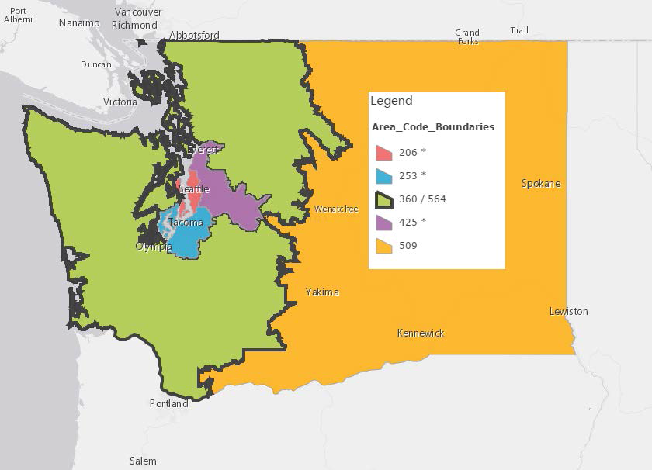
Overlay anticipated to occur first in area code – 360 NPA by 1st Quarter of 2018.
* The remaining western Washington area codes are projected to exhaust as follows: NPA 206 in 2027, NPA 253 in 2046, and NPA 425 in 2040.

ATTACHMENT 2

NPA IMPLEMENTATION TIMELINE TABLE-INDUSTRY PROPOSED

Event | Timeframe | Date
Overlay Implementation Period | 13 months
Start Network Preparation and Customer Education | 6 months | July 28, 2016
Continued customer education and permissive seven- and ten-digit dialing period (Calls between 206, 360, 253, 425 area codes dialed using seven or ten-digits) | Permissive ten-digit dialing has been in effect since 2001 in western Washington  (6 month restart period) | January 28, 2017
Start of Mandatory ten-digit dialing for all western Washington area codes | 1 month | July 29, 2017
Effective date of 564 area code | One month after start of mandatory ten-digit dialing | August 28, 2017

Order Implementing Area Code Relief Plan, Docket UT-991535 (May 10, 2000).
An overlay requires ten-digit local dialing as a federal mandate in 47 CFR 52.19 (3)(ii) and the commission has kept seven-digit and ten-digit permissive dialing in place since approving the initial 564 NPA overlay plan for western Washington.
Order Suspending Area Code Relief Plan, Docket UT-991535 (September 5, 2001).
Over the last 15 years, the commission continued a proactive approach to improving the efficiency with which number resources are used and curbing area code exhaust and number depletion throughout Washington. Some of the actions taken by the commission were a) rate center consolidations (304 rate centers in 1998; 235 today) that allowed prefixes to cover wider geographic areas, b) mandatory Thousand-Block-Number Pooling, and c) reclamation of unused blocks and codes from service providers.
An area code reaches exhaust when all of the available central office codes (or prefixes) within that area code have been assigned. Area code relief, by means of an overlay or a geographic split, must be implemented to ensure an adequate supply of telephone numbers remains available for assignment.
CenturyLink, the Washington Independent Telecommunications Association, AT&T Corp. (Teleport Communications America, SBC Long Distance, Cricket Communications, New Cingular Wireless PCS, LLC); T-Mobile West LLC; MCI Metro Access transmission Services, LLC dba Verizon Business Access Transmission Services; Sprint Communications Company L.P. (Virgin Mobile USA, L.P.)
Docket UT-991535, Order Implementing Area Code Relief Plan, May 10, 2000, Page 5, para 11.
See FCC Order DA 14-842

