www.fairpoint.com

908 W. Frontview

Dodge City, KS 67801

 August 31, 2016

Mr. Steven King

Executive Director and Secretary

Washington Utilities and Transportation Commission

1300 South Evergreen Park Drive SW

Olympia WA 98504-7250

RE: Petition of Ycom Networks, Inc. d/b/a Fairpoint Communications, to Receive Support From the State Universal Communications Services Program –Supplemental; Docket UT-160981

Dear Mr. King:

On August 1, 2016, YCOM Networks, Inc. d/b/a FairPoint Communications filed a petition to the Washington Utilities and Transportation Commission to receive support from the State Universal Communications Services Program established in RCW 80.36.650 for the fiscal year ending June 30, 2017.

Per staff review, corrections were made to several documents, including the Petition and exhibits. Attached for filing the following replacement documents:

Petition for USF Support (corrected)

YCOM Confidential Statistics (omitted from the original filing – a redacted version is also included)

Exhibit 3 – Demonstration of Risk (corrected)

Exhibit 4 – Confidential Financial Statement (corrected - a redacted version is also included)

Exhibit 7 – Corporate Certifications Certificate

This filing contains information which is is being filed as CONFIDENTIAL pursuant to WAC 480-07-160. YCOM Networks, Inc. d/b/a FairPoint Communications believes that public availability of this information could cause potential, but irreparable, injury to the company because of the nature of this information. The submitted data includes specific proprietary information about the company's past, present and future operations, access line counts, and financial disclosures. FairPoint requests confidential treatment of this information as it is competitively sensitive and is not normally released to the public.

Please contact Beth Westman at 207.535.4249 or bwestman@fairpoint.com with any questions or concerns regarding this filing.

Sincerely,

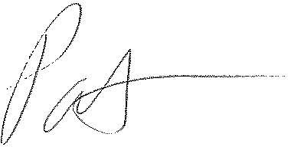

Patrick L. Morse

Senior VP Governmental Affairs

FairPoint Communications

P: 620-227-4409

F: 620-227-8576