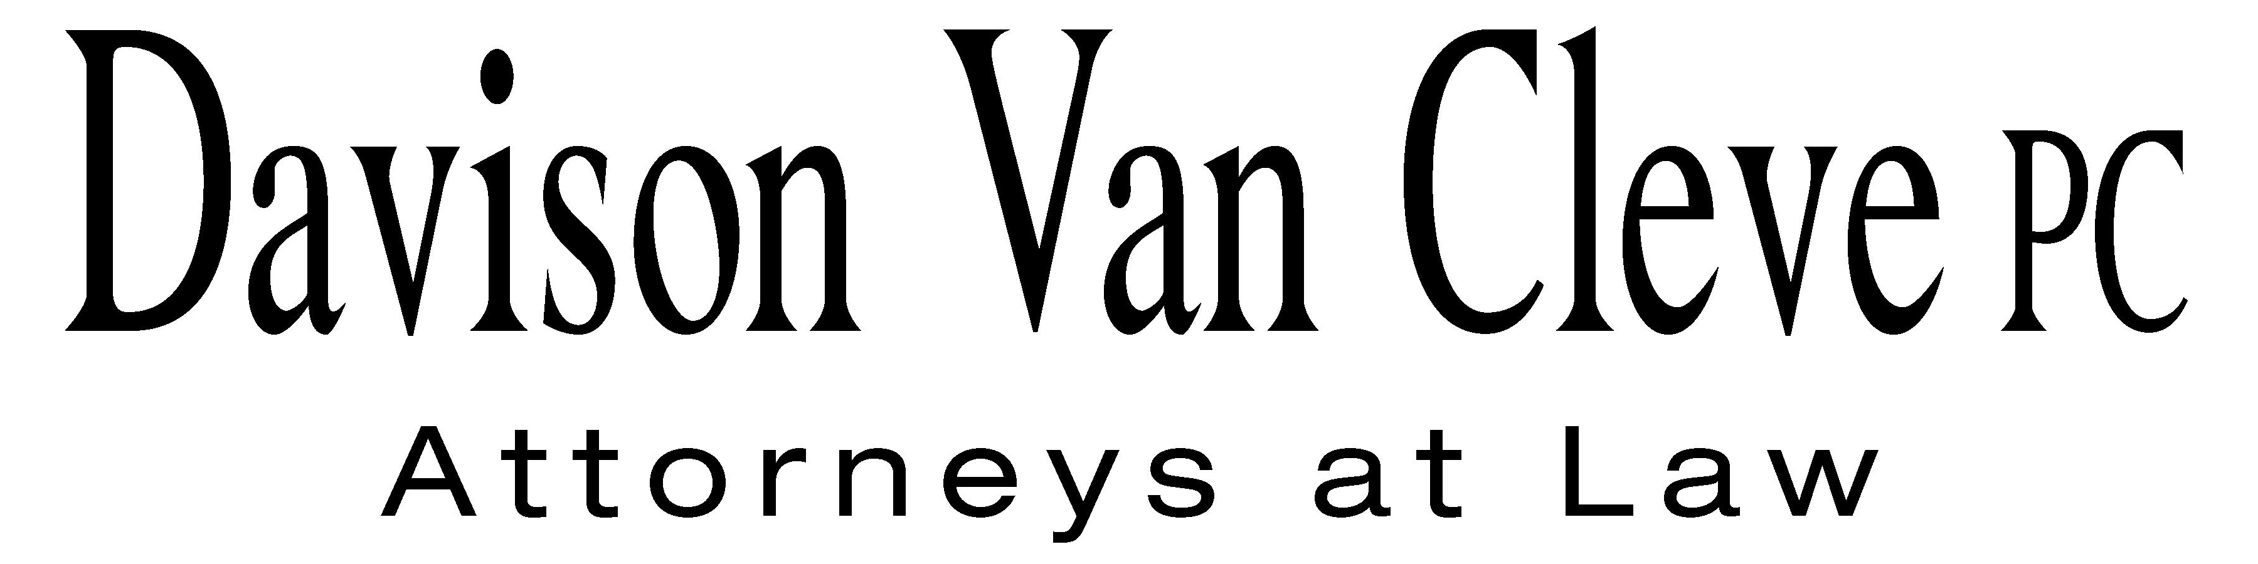

TEL (503) 241-7242 ● FAX (503) 241-8160 ● mail@dvclaw.com

Suite 400

333 SW Taylor

Portland, OR 97204

January 8, 2008

### Via Email and Federal Express

# Carole J. Washburn

Secretary

Washington Utilities and Transportation Commission

PO Box 47250

1300 S Evergreen Park Drive SW

Olympia, WA 98504-7250

Re: In the matter of Joint application of Puget Holding, LLC, and Puget Sound Energy, Inc., reflecting a merger agreement.

## **Docket No. U-072375**

Dear Ms. Washburn:

Enclosed please find an original and eighteen (18) copies each of the following documents for filing in the above-captioned matter:

* the Petition to Intervene of the Industrial Customers of Northwest Utilities; and
* the Notice of Appearance of Melinda J. Davison, Irion A. Sanger, and Andrew N. Harris on behalf of the Industrial Customers of Northwest Utilities.

Please return one file‑stamped copy of each document in the postage‑prepaid envelope provided. Thank you for your assistance.

Sincerely yours,

Brendan E. Levenick

Enclosures

cc: Service List

##### CERTIFICATE OF SERVICE

I hereby certify that I have this day served the foregoing documents upon all parties of record in this proceeding by mailing a copy thereof in a sealed, first-class postage prepaid envelope to each individual’s last-known address, as listed below.

DATED in Portland, Oregon this 8th day of January, 2008.

Davison Van Cleve, P.C.

Brendan E. Levenick

|  |  |  |
| --- | --- | --- |
| **PUGET SOUND ENERGY**  TOM DEBOER  PO BOX 97034 PSE-08N  BELLEVUE WA 98009-9734  tom.deboer@pse.com | **PERKINS COIE**  SHEREE CARSON  JASON KUZMA  10885 N.E. FOURTH STREET STE 700 BELLEVUE WA 98004-5579  scarson@perkinscoie.com  jkuzma@perkinscoie.com | |
| **CHRISTOPHER LESLIE**PUGET HOLDINGS, LLC125 WEST 55TH STREET FL 22NEW YORK NY 10019chris.leslie@macquarie.com **QUALITY FOOD CENTERS, INC.**  10116 N.E. 8TH STREET  BELLEVUE WA 98004 | **DEPARTMENT OF THE NAVY**  NORMAN FURUTA  1455 MARKET STREET STE 1744  SAN FRANCISCO CA 94103-1399  norman.furuta@navy.mil  **FRED MEYER STORES, INC**  3800 SOUTHEAST 2ND STREET  PORTLAND OR 99202 | |
| **THE KROGER CO.**  ATTN: CORPORATE ENERGY MANAGER (G09)  1014 VINE STREET  CINCINNATI OH 45202  dgeorge@kroger.com  **DEPARTMENT OF THE NAVY**  SCOTT JOHANSEN  1220 PACIFIC HIGHWAY  SAN DIEGO CA 92132  scott.johansen@navy.mil | **BOEHM, KURTZ & LOWRY**  MICHAEL L KURTZ  36 E. SEVENTH ST. STE 1510  CINCINNATI OH 45202  mkurtz@bkllawfirm.com  **ATTORNEY GENERAL OFFICE**  ROBERT D CEDARBAUM  DON TROTTER  SALLY BROWN  STATE MAIL STOP 40128  bcedarba@wutc.wa.gov  dtrotter@wutc.wa.gov  sjohnston@wutc.wa.gov | |
| **OFFICE OF THE ATTORNEY GENERAL**  SIMON FFITCH  800 FIFTH AVENUE STE 2000  SEATTLE WA 98104-3188  simonf@atg.wa.gov | **MARTHA BRANDON**  PO BOX 10369  BAINBRIDGE ISLAND WA 98110  mebrandon@qwest.net | |
| **ROLAND STOLIS**  13002 NORTHEAST 101ST PLACE  KIRKLAND WA 98033  vidor@nwlink.com  **PATRICIA WOEHRLIN**  717 15TH STREET  BELLINGHAM WA 98225 | | **MARV CYPERT**  4137 SHINCKE RD  OLYMPIA WA 98506  **BILL PARKER**  9512 232ND STREET SOUTHWEST  EDMONDS WA 98020 |