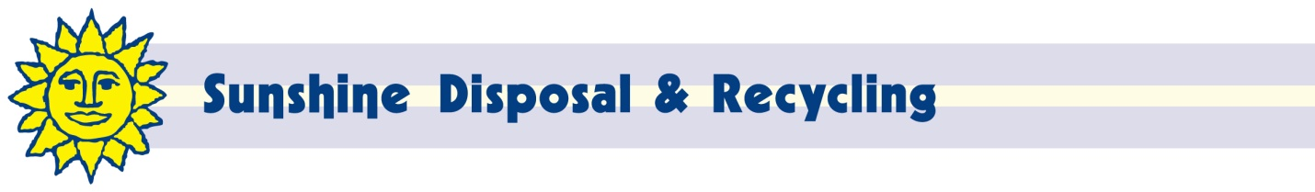

December 10, 2015

Steven V. King, Executive Director and Secretary

Washington Utilities and Transportation Commission

PO Box 47250

Olympia, WA 98504-4720

Dear Mr. King:

Enclosed are proposed revisions to Tariff 10.1 of Ada-Lin Waste Systems, Inc, d/b/a Sunshine Disposal & Recycling (G-104).

The purpose of this filing is to adjust rates to reflect increased Lincoln County program and disposal fees. The program fee has increased by $5.00 since our last general rate increase in 2010.

The net impact of these changes will increase revenue approximately $4,200 or about .7% annually. Customers will be notified of the rate change on their next regular billing.

We request waiver from the requirements of WAC 480-07-520 due to the fact that this rate change only covers changes in governmental fees.

If I can be of any further assistance, please contact me at 509-924-5678 x217 or 509-252-3500 (fax) or at [johnl@sunshinedisposal.com](mailto:johnl@sunshinedisposal.com).

Respectfully,

John Lloyd

Chief Financial Officer