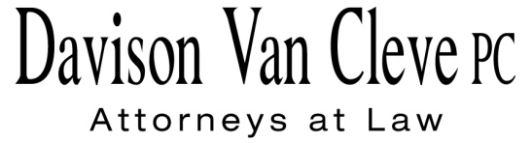

TEL (503) 241-7242 ● FAX (503) 241-8160 ● mail@dvclaw.com

Suite 400

333 SW Taylor

Portland, OR 97204

October 11, 2013

***Via E-Mail and Federal Express***

Mr. Steven V. King

Acting Executive Director and Secretary

Washington Utilities and Transportation Commission

P.O. Box 47250

1300 S. Evergreen Park Drive

Olympia, WA 98504-7250

Re: In the Matter of WUTC v. PacifiCorp

**Docket No. UE-130043**

Dear Mr. King:

Enclosed for filing in the above-referenced docket, please find the original and thirteen (13) copies of the Post-Hearing Reply Brief of Boise White Paper, LLC.

Thank you for your assistance, and please do not hesitate to call our office with any questions.

Sincerely,

*/s/ Madeleine P. Amodio*

Madeleine P. Amodio

Enclosures

cc: Service List

**CERTIFICATE OF SERVICE**

I HEREBY CERTIFY that I have this day served the Post-Hearing Reply Brief of Boise White Paper, LLC upon all parties of record in this proceeding by causing a copy thereof to be sent via electronic mail and First Class U.S. Mail, postage prepaid, to each party’s last-known address, as shown below.

Dated at Portland, Oregon, this 11th day of October, 2013.

*/s/ Madeleine P. Amodio*

Madeleine P. Amodio

|  |  |  |  |  |  |  |  |
| --- | --- | --- | --- | --- | --- | --- | --- |
| |  |  | | --- | --- | | **ROBERT D. CEDARBAUM**  ASSISTANT ATTORNEY GENERAL  WUTC  P.O. BOX 40128  OLYMPIA, WA 98504-0128  bcedarba@wutc.wa.gov | **SARAH K. WALLACE**  SENIOR COUNSEL  PACIFIC POWER & LIGHT CO.  825 NE MULTNOMAH STE 1800  PORTLAND, OR 97232  sarah.wallace@pacificorp.com | | **LISA W. GAFKEN**  OFFICE OF THE ATTORNEY GENERAL  800 FIFTH AVENUE, SUITE 2000  SEATTLE, WA 98104-3188  lisa.gafken@atg.wa.gov | **BRAD M. PURDY**  ATTORNEY AT LAW  2019 N. 17TH ST.  BOISE, ID 83702  bmpurdy@hotmail.com | | **KATHERINE MCDOWELL**  MCDOWELL RACKNER & GIBSON PC  419 SOUTHWEST 11TH AVENUE  SUITE 400  PORTLAND, OR 97205-2605  katherine@mcd-law.com |  | |  |
|  |  |