Steven King

Executive Director and Secretary

Washington Utilities and Transportation Commission

1300 S. Evergreen Park Dr. S.W.

Olympia WA 98504-7250

June 16th 2016

RE: Report of the Toledo Telephone Co., Inc. under the Washington Universal Service Communications Program in Compliance with WAC 480-123-130

Dear Mr. King;

Enclosed please find the above referenced filing of The Toledo Telephone Company, Inc. Docket Number UT-151612

Should you have any questions or require additional information please contact me directly.

Best regards,

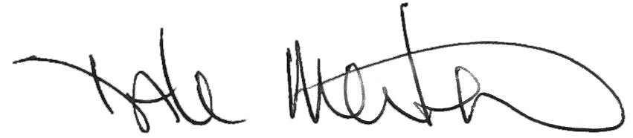

Dale Merten

C.O.O.

ToledoTel

306-864-2044

[dale@toledotel.com](mailto:dale@toledotel.com)

Enclosures