**CenturyLink**

Gary Kepley

600 New Century Parkway

New Century, Kansas 66031

Tel: 913-353-7080 Fax: 913-791.2375

Mailstop: KS00290207-1D207

E mail: Gary.Kepley@CenturyLink.com

June 16, 2015

The Federal Communications Commission’s (“FCC”) November 18, 2011 USF/ICC Transformation Order, FCC 11-161 (WC Docket No. 10-90), requires price cap carriers seeking CAF ICC support to file data establishing the amount of the price cap carrier’s eligible CAF ICC funding per 47 C.F.R. §54.304(c)(1).

Below are CenturyLink’s anticipated CAF ICC support and Access Recovery Charge Revenue amounts submitted with its 2015 Annual Access Tariff Filing with the FCC.

|  |  |  |
| --- | --- | --- |
| Holding Company Eligible Recovery | Holding Company Maximum ARC Revenues | Maximum CAF ICC Support |
| $162,330,539 | $201,260,159 | $0 |

Please call me at 913-353-7080 if you have any questions regarding this filing.

Sincerely,

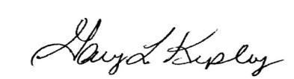

Gary Kepley

Director – Regulatory Operations