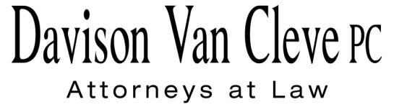

TEL (503) 241-7242 ● FAX (503) 241-8160 ● jog@dvclaw.com

Suite 400

333 S.W. Taylor

Portland, OR 97204

January 11, 2016

### Via E-mail and Federal Express

Mr. Steven V. King

Executive Director & Secretary

Washington Utilities & Transportation Commission

1300 S. Evergreen Pk. Dr. S.W.

P. O. Box 47250

Olympia, WA 98504-7250

Re: WUTC v. Avista Utilities

**Docket UE-151148**

Dear Mr. King:

The Industrial Customers of Northwest Utilities requests a change to the service list in the above-referenced docket. Please remove Melinda J. Davison.

Thank you for your assistance. If you have any questions, please do not hesitate to call.

Sincerely,

*/s/ Jesse O. Gorsuch*

Jesse O. Gorsuch

cc: Service List

##### CERTIFICATE OF SERVICE

I hereby certify that I have this day served the attached Request to Change Service List upon the parties shown below by sending a copy via electronic mail and by mailing a copy via First Class U.S. Mail, postage prepaid.

DATED this 11th day of January, 2016.

Davison Van Cleve, P.C.

*/s/ Jesse O. Gorsuch*

Jesse O. Gorsuch

|  |  |  |  |
| --- | --- | --- | --- |
| |  |  | | --- | --- | | **AVISTA CORPORATION**  David. J. Meyer  Kelly O. Norwood  Po Box 3727  1411 E. Mission Ave,  MSC-27 Spokane, WA 99220-3727 david.meyer@avistacorp.com  kelly.norwood@avistacorp.com  AvistaDockets@avistacorp.com  **WASHINGTON UTILITIES & TRANSPORTATION COMMISSION**  Patrick Oshie Assistant Attorney General PO Box 40128 Olympia, WA 98504-0128  poshie@utc.wa.gov | **OFFICE OF THE ATTORNEY GENERAL – PUBLIC COUNSEL**  Simon ffitch  Lisa Gafken  800 Fifth Avenue, Suite 2000  Seattle, WA 98104-3188  simonf@atg.wa.gov  Lisaw4@atg.wa.gov | |  |