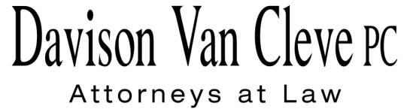

TEL (503) 241-7242 ● FAX (503) 241-8160 ● mail@dvclaw.com

Suite 400

333 S.W. Taylor

Portland, OR 97204

April 25, 2014

### Via E-mail and Federal Express

Mr. Steven V. King

Executive Director

Washington Utilities & Transportation Commission

1300 S. Evergreen Pk. Dr. S.W.

P. O. Box 47250

Olympia, WA 98504-7250

Re: In the Matter of PACIFICORP

Advice No. 14-03 – Hydro Investment Adjustment

**Docket No. UE-140617**

Dear Mr. King:

Enclosed please find an original and twelve (12) copies of the Petition to Intervene and Opposition of the Industrial Customers of Northwest Utilities.

Thank you for your assistance. If you have any questions, please do not hesitate to contact our office.

Sincerely,

*/s/ Jesse O. Gorsuch*

Jesse O. Gorsuch

Enclosures

cc: Service List

##### CERTIFICATE OF SERVICE

I hereby certify that I have this day served the attached Petition to Intervene and Opposition upon all parties in this proceeding by sending a copy via electronic mail and by mailing a copy via First Class U.S. Mail, postage prepaid, to the following parties at the following addresses.

DATED this 25thday of April, 2014.

Davison Van Cleve, P.C.

*/s/ Jesse O. Gorsuch*

Jesse O. Gorsuch

|  |  |
| --- | --- |
| **PACIFICORP**  SARAH K. WALLACE  825 NE MULTNOMAH, SUITE 1800  PORTLAND, OR 97232  sarah.wallace@pacificorp.com | **PACIFICORP**  WASHINGTON DOCKETS  825 NE MULTNOMAH, SUITE 2000  PORTLAND, OR 97232  washingtondockets@pacificorp.com |
| **WASHINGTON UTILITIES & TRANSPORTATION COMMISSION**  SALLY BROWN  PO BOX 40128  OLYMPIA, WA 98504-0128  sbrown@utc.wa.gov |  |
|  |  |
|  |  |