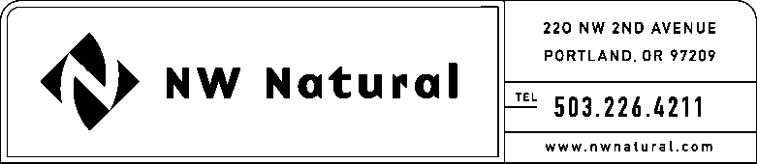

# GAIL A. HAMMER

Tariff and Regulatory Compliance

Tel: 503.226.4211, ext. 5865

Fax: 503.721.2516

email: gail.hammer@nwnatural.com

August 31, 2015 NWN Advice No. WUTC 15-05

***VIA ELECTRONIC FILING***

Steven King, Executive Director and Secretary

Washington Utilities and Transportation Commission

1300 S. Evergreen Park Drive, S.W.

P.O. Box 47250

Olympia, Washington 98504-7250

**RE:** **Schedule G, Energy Efficiency Services and Programs – Residential and Commercial**

Northwest Natural Gas, dba NW Natural (“NW Natural” or the “Company”), the following tariff sheet stated to become effective with service on and after **October 1, 2015**:

Eleventh Revision of Sheet G.1,

Schedule G,

“Energy Efficiency Services and Programs – Residential and Commercial.”

The purpose of this filing is to revise the Company’s Energy Efficiency Plan (“Plan”) which by reference on Sheet G.1 is part of the Company’s Tariff. The Plan is revised to more clearly define energy-related costs in the description of On-the-Bill repayment services and to specify the loan amount available through On-the-Bill repayment services.

It is challenging for the Energy Trust to monitor that no more than 25% of loaned dollars may be used for non-energy related measures due to the invoicing practices of contractors. The updated language requires loans to include only those costs that are directly attributable to the commissioning and installation of the qualifying measure, costs incurred to comply with applicable building code, mechanical code, or other pertinent regulations, or costs incurred to meet any technical specifications established by the Energy Trust. Craft3, the non-profit community development financial institution lender, does not foresee any difficulty in managing to the state loan fund guidelines if the 25% threshold is removed.

Also, language is added to the Plan to specify the minimum and maximum loan amounts available through Craft3.

There are no budget changes as a result of the proposed change.

The Company has shared this filing with its Energy Efficiency Advisory Group.

The Company respectfully requests that the tariff sheets filed herein be approved to become effective with service on and after October 1, 2015.

As requested by WAC 480-80-103(4)(a), I certify that I have authority to issue tariff revisions on behalf of NW Natural.

A copy of the filing is available for public inspection in the Company’s main office in Portland, Oregon and on its website at [www.nwnatural.com](http://www.nwnatural.com).

Please address correspondence on this matter to me with copies to the following:

eFiling

NW Natural Rates & Regulatory Affairs

220 NW Second Avenue

Portland, Oregon 97209

Telecopier: (503) 721-2516

eFiling@nwnatural.com

If you have any questions, please contact me at 1-503-226-4211, extension 5865.

Sincerely,

NW NATURAL

*/s/ Gail A. Hammer*

Gail A. Hammer

Rates & Regulatory Affairs

Attachments