June 11, 2012

David Danner

Executive Director and Secretary

Washington Utilities and Transportation Commission

1300 S. Evergreen Park Dr. S.W.

PO Box 47250

Olympia, WA 98504-7250

RE: Docket No. UE-111881 – Puget Sound Energy Presentation of the Biennial Conservation Plan, Ten-year Achievable Conservation Potential, and Biennial Conservation Target pursuant to WAC 480-109-010(3) and RCW 19.285, the Energy Independence Act

The NW Energy Coalition (“Coalition”) appreciates the opportunity to offer these comments in support of Puget Sound Energy’s (“PSE”) proposed 2012-2013 biennial conservation target of 76.0 aMW to meet the requirements in RCW 19.285.040(1). We also support the proposed modifications to the “conditions list” originally approved in Docket No. UE-100177.

On December 7, 2011, the Coalition filed comments in response to the Commission’s November 4, 2011 Notice of Opportunity to Comment in this docket. Since that time, we worked with PSE, WUTC Staff, Public Counsel and ICNU to further modify the conditions list for your consideration.

In particular, the Coalition worked with PSE to develop conditions related to assessment of production efficiency potential. Provision 12 in the proposed conditions list addresses the concerns raised by the Coalition in our December 7, 2011 comments. Specifically, this condition requires PSE to examine the feasibility of reducing energy consumption in electric power production facilities it wholly or partly owns outside of Washington State. In addition, this condition sets a schedule for PSE to file a petition for a declaratory order concerning whether the Energy Independence Act requires PSE to pursue cost-effective opportunities for turbine upgrades and other output efficiency improvements in addition to efficiency measures that reduce overall consumption at production facilities. We are pleased to see these conditions reflected in Attachment B to Staff’s June 14 Memo, “Proposed Conditions List for PSE in UE-111881.”

Thank you for the opportunity to provide these comments. I plan to participate by phone in the Open Meeting on June 14 and would be happy to answer any questions at that time.

Sincerely,

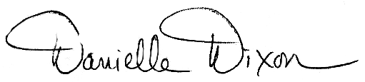

Danielle Dixon

Senior Policy Associate

NW Energy Coalition

811 1st Ave Suite 305

Seattle, WA 98104