Puget Sound Energy

Meter and Billing Performance Annual Report

Annual Reporting Period:

January 1, 2015 - December 31, 2015

Filed on January 29, 2016

This Page Intentionally Left Blank

Table of Contents
Introduction 4
Summary Progress to Date 5
Meter and Billing Performance Summary 5
Resolution Results for Unassigned Energy Usage 5
Resolution Results for Stopped Meters 6
Zero Consumption 180-Day Customer Notification Report 7
Tracking and Reporting of Meter/Billing Issues 10
Issues Discussion 10
Process Improvement 11
Appendix A: Background, Definitions, and Standards 13
Background 13
Definitions 14
Meter and Billing Performance Standards 14
Appendix B: Zero Consumption 180- Day Investigation Customer Notice 15
Customer Notice 15

Introduction

This is Puget Sound Energy’s (“PSE’s”) third Meter and Billing Performance Annual Report under the revised Meter and Billing Performance Standards set forth in the Partial Settlement in Order 8 of consolidated Docket Nos. UE-111048 and UG-111049 (“Partial Settlement”) for periods starting January 1, 2015 to December 31, 2015. PSE met the standard for the identification and the correction of 98% of the stopped meters or the meters with unassigned energy usage within 12 months from the initial occurrence of the problem. Overall, 39 meters (0.23% of the meter problems) were identified and corrected outside of the 24-month timeframe.

The meter and billing performance standards per Partial Settlement paragraph 13 (“Meter and Billing Performance Standards” or “Meter and Billing Standards”) are:
- PSE will identify and correct 98 percent of all stopped meter and unassigned energy usage meter problems for both gas and electric meters within 12 months from initial occurrence of the problem.
- PSE will identify and correct all stopped meter and unassigned energy problems for both gas and electric meters within 24 months from the initial problems report.

This report also discusses the results of the on-going zero Consumption 180-day customer notification requirement (per Partial Settlement paragraph 18).

The layout and elements of this report are consistent with the draft annual meter and billing report outline reviewed and discussed with the Commission Staff on September 27, 2013. Staff provided additional comments and suggestions via an e-mail on October 30, 2013, which have been incorporated in this report.

Summary Progress to Date

Meter and Billing Performance Summary
For the 2015 annual reporting period, PSE met the Meter and Billing Performance Standard for unassigned energy usage (“UEU”) meter cases for the 12-month threshold at 99% and barely missed the 24-month threshold as 32 out of the 13,070 UEU meter problems were identified and corrected outside the threshold.
For the stopped meter cases, PSE is in full compliance with performance standard for the 12-month threshold at 98% and again narrowly fell short of the 24-month threshold as 7 stopped meter problems (out of the 3,578 stopped meters) were identified and corrected outside the threshold.
The outlier meter issues will be discussed in the Tracking and Reporting of Meter/Billing Issues section of this report.
Percentages shown in this report are rounded to the nearest whole percentages and reported to the accuracy of the decimal place of the Meter and Billing Performance Standards.

Resolution Results for Unassigned Energy Usage
The table below provides the total number of meters with Unassigned Energy Usage that had been identified and correctly billed between January 1, 2015, and December 31, 2015. The time measure is based on the date the customer moved in to the location (i.e., the date of the customer’s initial unauthorized usage to the last billing-cycle date the adjustment (i.e., the date that the back bill was issued).
 | Within 6 Months | Within 12 Months | Within 24 Months | Above 24 Months | Total Meters | Within 12 Months | Within 24 Months | Exceeds 24 Months | Total Results
Electric | 6,749 | 420 | 95 | 22 | 7,286 | 98% | 1% | 0% | 100%
Gas | 5,078 | 640 | 56 | 10 | 5,784 | 99% | 1% | 0% | 100%
Total | 11,827 | 1,060 | 151 | 32 | 13,070 | 99% | 1% | 0% | 100%

Resolution Results for Stopped Meters
The table below provides the total number of stopped meters that had been identified and correctly back billed between January 1, 2015, and December 31, 2015. The time measure is based on the starting date of the billing adjustment (i.e., the date when the commodity was accurately measured) to the end date of the billing adjustment (i.e., the date that the customer’s meter again accurately records usage) as prescribed in the paragraph 14 of the Partial Settlement.
 | Within 6 Months | Within 12 Months | Within 24 Months | Above 24 Months | Total Meters | Within 12 Months | Within 24 Months | Exceeds 24 Months | Total Results
Electric | 441 | 72 | 9 | 1 | 523 | 98% | 2% | 0% | 100%
Gas | 2,711 | 299 | 39 | 6 | 3,055 | 99% | 1% | 0% | 100%
Total | 3,152 | 371 | 48 | 7 | 3,578 | 98% | 1% | 0% | 100%

Zero Consumption 180-Day Customer Notification Report

As part of the PSE’s Partial Settlement commitments, PSE has been carried out an on-going process to notify each customer with a meter that showing zero consumption for 180 consecutive days. This section of the report summarizes the results of the customer notification process for the period of January 1, 2015, through December 31, 2015.

In the current customer notification process, started on October 1, 2014, a letter is sent to a customer whenever the 180-day zero consumption threshold is met. An example of the customer notification letter is included for reference in Appendix B: Zero Consumption 180-Day Customer Notice.
In 2015, PSE sent out 8,899 zero consumption 180-day notification letters, 3,699 electric cases and 5,200 natural gas cases. 8,005 of the 8,899 cases are customer confirmed valid zero usage cases and did not require any further PSE action.

 | Contact Cases Initiated | Confirmed Zero-usage Cases | Resolved Cases | Cases with Billing Adjustments | On Going Cases
Electric | 3,699 | 3,269 | 22 | 16 | 392
Gas | 5,200 | 4,736 | 22 | 72 | 370
Total | 8,899 | 8,005 | 44 | 88 | 762

The chart below shows the breakdown of customer notifications generated by fuel and by month 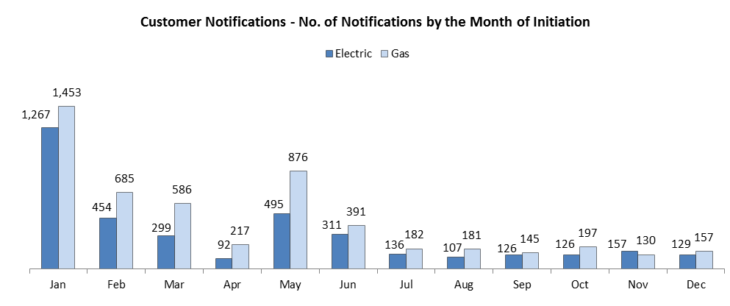
During the reporting period of January 2015 through December 2015, 3,307 of the 3699 electric notification cases were resolved. 392 cases are still pending for resolution. The chart below shows the resolution status of these 3,307 electric cases by the month of completion.

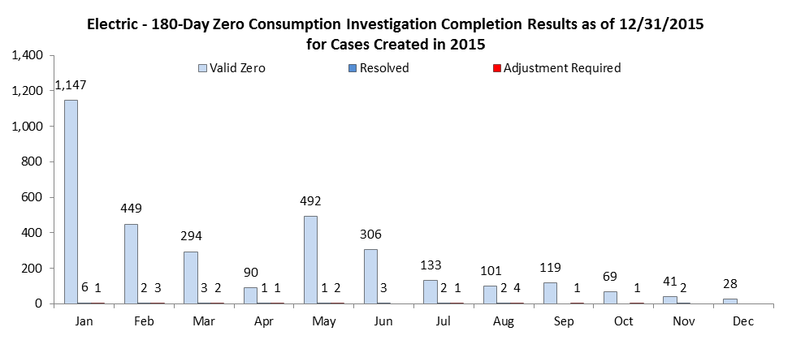

4,830 out of 5,200 natural gas notification cases were resolved. 370 cases are still pending for resolution. 4,736 or 98% of the completed cases are customer-confirmed zero-usage meters. 22 cases were resolved prior to mailing the customer notification letter. 72 cases or 2% of the natural gas cases required a billing adjustment.
The chart below shows the resolution status of the 2015 natural gas 180-day zero consumption notification cases by the month of completion.

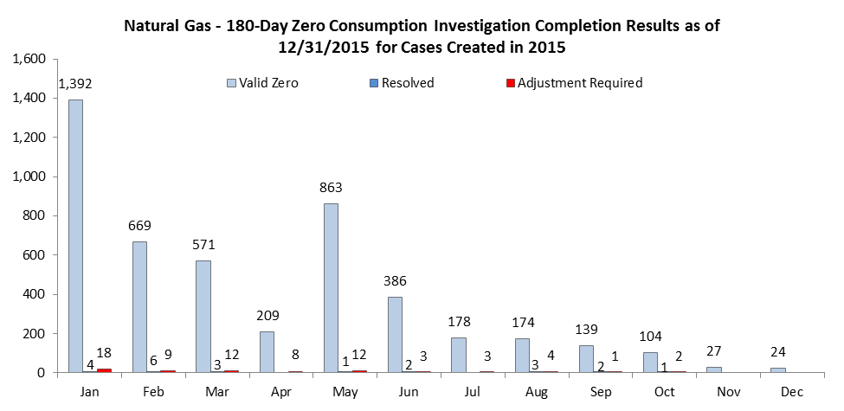

The Chart below shows the average length and the amount of bill adjustments for the 16 electric meters identified by the customer notification process that required a billing adjustment. There was no adjustment issued in November and December 2015.

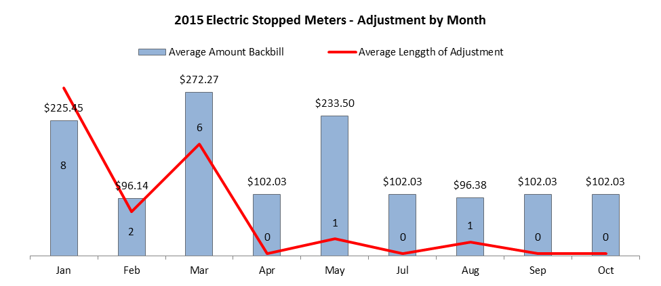

The Chart below shows the average length of back bill and the average back bill dollar amount for the 72 gas meters identified by the customer notification process that required a billing adjustment. There was no adjustment issued in November and December 2015.

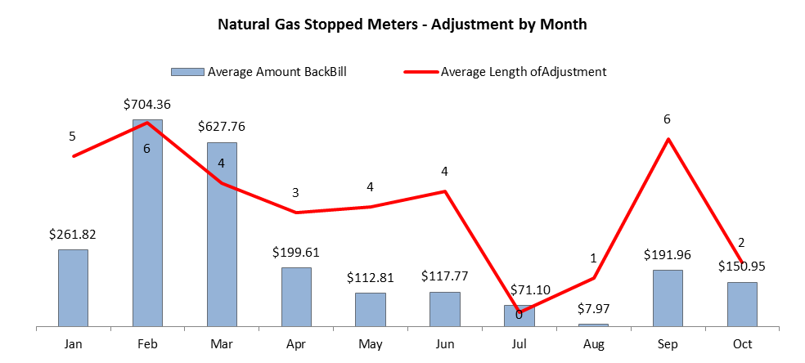

Tracking and Reporting of Meter/Billing Issues

Issues Discussion
This section explains the meter cases that were corrected outside the Meter and Billing Performance Standards and any other tracking and reporting issues.

Stopped Meters

The table below summarizes the stopped meter results by Meter and Billing Performance Standards for the applicable reporting period of January 1, 2015, through December 31, 2015 by energy.

Stopped Meters Results | Within 12 Months | Within 24 Months | Greater than 24 Months | Total
Electric | 513 | 9 | 1 | 523
Gas | 3010 | 39 | 6 | 3,055
Total | 3,523 | 48 | 7 | 3,578

The 7 electric and natural gas meters that were resolved outside of the 24-month time measurement were “poor performing” meters. These meters showed sporadic usage over a long period of time rather than constant zero consumption. Therefore, the initial period of time when these meters were not registering usage did not meet the thresholds for identification in the stopped meter process due to the sporadic usage. When the stopped meter thresholds were finally reached, the time measure would be longer than a meter that was completely stopped.
The resulting length of billing adjustments for these meters include the period of time where the zero consumption occurred through the time the meters were repaired or replaced and the period associated with the sporadic usage prior to completely stopping, thus resulting in a longer time measure than would have occurred if the meter had simply stopped.
There are two contributing factors that results in the 48 meter cases that exceeded the 12-month time measurement:
- 35 of 48 meters were a “poor performing” meter as described above that would take an extended period for a meter to completely stop.

- 13 of 48 meters that showed usage after first identified by the automatic tracking of the stopped meter review process but before the completion of the investigation process. Typically, as a meter is identified as a probable stopped meter it is automatically logged into the stopped meter review process. When a meter resumed usage by itself prior to the manual investigation process taking place, the meter is no longer considered a stopped meter and is therefore removed from the automatic tracking of the stopped meter review process. However, if the meter has been move to the investigation process, it will remain in the automatic tracking of the stopped meter review process as the investigation process is still on going. For this particular type of meter issues, the length of the bill adjustment would include the time when the sporadic usage begun to the time that the investigation process confirms that the meter is indeed accurately records usage. Therefore, it takes a longer time to correct this type of meter cases.
It is important to review the performance in the context of PSE’s overall billing performance. In 2014, PSE issued 2,521 stopped meter bills to customers and 32 of the 2,521 adjustments exceeded the 24 months length of backbill. In 2015, there were 3,578 stopped meter backbilling adjustments, 7 of the 3,578 adjustments exceeding the 24 months mark. It is a great improvement in the backbilling ratio of 1.3% in 2014 to only 0.2% in 2015 for the adjustments that were 24 months or longer.

Unassigned Energy Usage Meters

The table below summarizes the Unassigned Energy Usage meter results by energy and by Meter and Billing Performance Standards for the applicable reporting period of January 1, 2015, through December 31, 2015.

UEU Meter Results | Within 12 Months | Within 24 Months | Above 24 Months | Total
Electric | 7,169 | 95 | 22 | 7,286
Gas | 5,718 | 56 | 10 | 5,784
Total | 12,887 | 151 | 32 | 13,070

The 151 meters that resolved within 24 months and the 32 meters fell outside of the 24-month threshold were not identified as a meter with UEU for an extended period of time due to a defect in PSE’s detection process. The problem has since been resolved. Further details and resolution of the issue is in the Process Improvement section below.

Process Improvement
As discussed in the 2013 and 2014 Report, PSE continues to look at ways to reduce the length of the backbilling and to address meter and billing performance issues.

Zero Consumption Detection Algorithms
PSE took actions in 2014 through 2015 to improve its meter and billing operations to reduce the time required to resolve poor performing and slow meter cases. As part of process improvement and on-going effort to meet the Performance Standards in the coming years, an analysis performed on the stopped meters with billing adjustment that spanned more than 24 months revealed that changes were needed in the detection process.
PSE took the following actions in 2015 to improve the meter detection process:
- During the first half of 2015, PSE began an analysis of its zero consumption detection algorithms with the algorithms vendor, Oracle DataRaker. Meters that had lengthy corrections in 2014 were analyzed to discover why the existing detection protocols did not identify them sooner.
- In April 2015, PSE implemented a new process whereby potential slowing meters were identified and investigated.
- In October 2015, based upon the aforementioned analysis, PSE and Oracle DataRaker implemented the improved zero consumption identification algorithms.

The new algorithms were able to identify sooner meters that might become a problem meter. The effectiveness of the algorithms can be attested by the increasing number of meter cases identified in 2015. 16,648 cases were identified in 2015 versus 11,564 cases in 2014. That is more than 5,000 additional cases identified from 2014, almost a 50% increase.
Enhanced Reporting Capabilities
Also, to improve the stopped meter and UEU identification and resolution processes, PSE enhanced its reporting capabilities. For what was previously a monthly or weekly report, now is a daily report with added automation capability for delivery at specific time and condition. The enhancement to the reporting capabilities is of major improvement because it provides meter case aging at the detail level, which allows PSE management to monitor closely the meter and billing performance, manage and forecast workforce deployment, and set or modify resource allocation and strategies going forward.
As discussed above, with the new Zero Consumption Detection Algorithms and the Enhanced Reporting Capabilities, PSE not only improved the visibility and identification of a potential meter problem in 2015 but also has been preparing to meet the challenges of 2016.
.

Appendix A: Background, Definitions, and Standards

Background
This meter and billing performance annual reporting is designed to meet the terms and requirements of the Partial Settlement RE: Meter and Billing Performance Standards (“Partial Settlement”) in consolidated Docket Nos. UE-111048 and UG 111049 Order 08 (“Order 08”) dated May 7, 2012. The layout and elements of this report are consistent with the draft annual meter and billing report outline reviewed and discussed with the Commission Staff on September 27, 2013. Staff provided additional comments and suggestions via an e-mail on October 30, 2013, which have been incorporated in this report. The annual report is due no later than January 31 for the preceding calendar year.
The Partial Settlement dictates both the meter and billing performance standards and reporting requirements for the quarterly reporting periods 2012 Q2 through 2013 Q2 and the annual reporting periods starting 2013. The quarterly performance standards were included 2012 Q2 through 2013 Q2 reports. The on-going annual Meter and Billing Performance Standards per Partial Settlement paragraph 13 are outlined in the Standards section of this appendix.
For the meter cases that are corrected outside of the Meter and Billing Performance Standards, PSE will retain the following information for these cases:
- Stopped meters: the last date when the commodity was accurately billed, the date the customer's meter again accurately records usage and the date PSE issues the back-bill.
- Unassigned energy usage meters: the date of the customer's initial unauthorized usage and the date that PSE issues of the back-bill.

In addition, there are two meter and billing processes that PSE committed in the Partial Settlement to carry out after June 1, 2012.
- A one-time investigation process to identify and correct, if needed, meters with zero consumption for 365 consecutive days.
- An on-going process to notify each customer with a meter that showing zero consumption for 180 consecutive days.
The results of the two processes are included in the following two sections of this report: One Time Zero Consumption 365-Day Investigation Completion Report – Final Report and Zero Consumption 180-Day Investigation Report, respectively.

Definitions
For purposes of the Meter and Billing Performance Standards time measurement will be as follows:
- Stopped meters: The performance standard for stopped meters will be measured from the last date commodity was accurately measured (the "initial occurrence" for stopped meters) to the date the customer's meter again accurately records usage.
- Unassigned energy usage meters: The performance standard for meters with unassigned energy usage will be measured from the date of the customer's initial unauthorized usage (the "initial occurrence" for unassigned energy usage) to the date the back bill was issued.

Meter and Billing Performance Standards
For effective starting June 1, 2013, and continuing until changed, the two Meter and Billing Performance Standards (“Meter and Billing Performance Standards”) are:
- PSE will identify and correct 98 percent of all stopped meter and unassigned energy usage meter problems for both gas and electric meters within 12 months from initial occurrence of the problem.
- PSE will identify and correct all stopped meter and unassigned energy problems for both gas and electric meters within 24 months from the initial problem.

Appendix B: Zero Consumption 180- Day Investigation Customer Notice

Customer Notice
The following is an example of the new customer notice PSE is sending to any customer with a meter that did not register any usage for 180 consecutive days.
