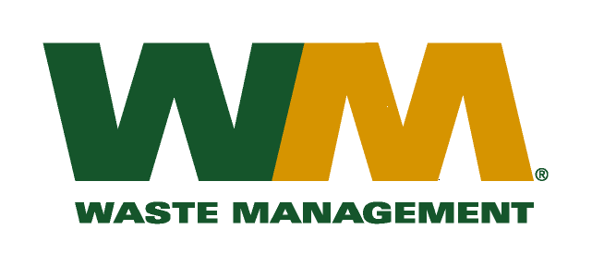

Washington Utilities and Transportation Commission

Chandler Plaza Building

1300 S. Evergreen Park Drive SW

P.O. Box 47250

Olympia, WA. 98504-7250

Subject: Waste Management of Skagit County, a division of Waste Management of Washington, Inc.(G-237); Tariff # 17

Dear Sirs:

Enclosed herein, please find revised pages 2, 22, 23, 24, 26, 31, 32, 33, 34 and 35 to the above-referenced tariff. These proposed revised tariff pages contain increased rates for residential and commercial garbage collection services. The requested rate increase is necessary in order to recover increased disposal costs at the Skagit County and Island County Transfer Stations. The Skagit County Commissioners approved the increase in disposal fees from $83.00 to $89.00 per ton as reflected in Skagit County Resolution R20090387. The Island County Commissioners approved the increase in disposal fees from $104.25 to $109.00 per ton as reflected in Island County Resolution C-124-09. The effective date of these disposal fee increases will be January 1, 2010. The increased rates, if approved by the commission, would approximately increase Company revenue by $142,000, and residential and commercial garbage rates by 3%. The effective date of the proposed tariff revisions is January 1, 2010.

Also enclosed for your review are our accounting workpapers and Resolutions R20090387 and C-124-09 for Skagit and Island counties, respectively. Upon approval by the Commission, affected customers will be notified of this rate increase on their next regularly scheduled billing. If you have any questions or need additional information, please contact me at (425) 814-7840.

Very Truly yours,

Michael A. Weinstein

Senior Pricing Manager, Pacific Northwest Market Area

cc: Elena Araujo

Tim Crosby

Joe Krukowski

Clerk of the Board, Snohomish County Chair