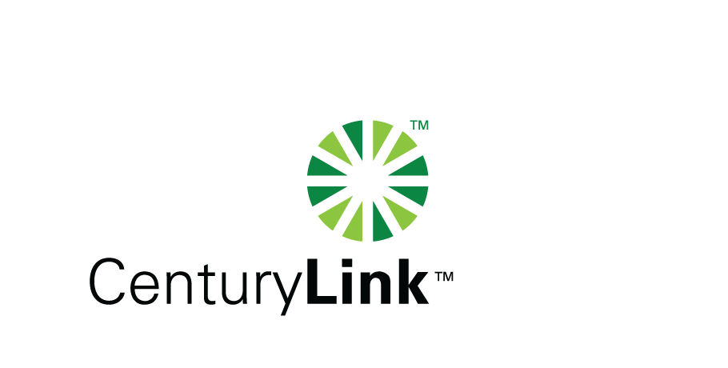

May 18, 2012

David Danner, Executive Director & Secretary

Washington Utilities & Transportation Commission

1300 S Evergreen Park Drive, SW

Olympia, Washington 98504-7250

Re: Washington Service Quality Reports for April 2012

Dear Mr. Danner:

Attached are the CenturyTel Service Quality Reports for the month of April 2012 in confidential and redacted versions.

The trouble reports per 100 access lines objective was met for the month of April.

Should you have any questions, please contact Mark Reynolds at (206) 345-1568 or by e-mail at mark.reynolds3@centurylink.com.

Sincerely,

Mark Reynolds

Enclosures: Installation/Repair Appointments

Service Activation in 5 Days

Trouble Per 100/Access Lines

Switching – Dial Tone Speed in 3 Seconds

Final Trunk Blockage (EAS and Toll)

Out of Service Trouble Cleared in 48 Hours

Not Out of Service Trouble Cleared in 72 Hours

Service Activation Delay 90-180 Days