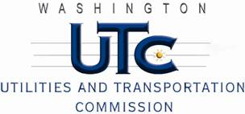

Memorandum

May 27, 2010

To: TR-091526 - File

From: Kathy Hunter, Deputy Assistant Director Transportation Safety

Subject: TR-091526 Tacoma Rail

Grade Crossing Protective Fund (GCPF) Project at 128th Street in Pierce County, Washington

On October 5, 2009, the Washington Utilities and Transportation Commission (Commission) awarded a GCPF grant totaling $20,000 to install a new bungalow with HXP-1 predictors and associated components at the 128th Street crossing in Pierce County. The USDOT number assigned to this crossing is 396682F.

On May 26, 2010, the applicant, Tacoma Rail submitted a request for reimbursement pursuant to Commission order. On May 25, 2010, Commission staff conducted a site visit and verified that the project is completed according to the specifications outlined in the order approving the grant.

Please close this docket.