www.fairpoint.com

908 W. Frontview

Dodge City, KS 67801

 August 1, 2016

Mr. Steven King

Executive Director and Secretary

Washington Utilities and Transportation Commission

1300 South Evergreen Park Drive SW

Olympia WA 98504-7250

RE: Petition of Ycom Networks, Inc. d/b/a Fairpoint Communications, to Receive Support From the State Universal Communications Services Program

Dear Mr. King:

Pursuant to Chapter 480-123 of the Washington Administrative Code ("WAC") including, but not limited to, WAC 480-123-110, YCOM Networks, Inc. d/b/a FairPoint Communications hereby petitions the Washington Utilities and Transportation Commission to receive support from the State Universal Communications Services Program established in RCW 80.36.650 for the fiscal year ending June 30, 2017. Included in this filing are the following exhibits:

Exhibit 1 – Corporate Organization Chart

Exhibit 2 – Affiliated Transactions

Exhibit 3 – Demonstration of Risk

Exhibit 4 – Financial Statement

Exhibit 5 – Audited Financial Statements

Exhibit 6 – RUS Form 479

Exhibit 7 – Corporate Operations Certificate

Exhibit 8 – Financial Accounting Certificate

Exhibit 9 – Continued Operations Certificate

Per WAC 480-07-160, Exhibit 4 has been marked as Confidential and YCOM Networks, Inc. d/b/a FairPoint Communications would appreciate such treatment of this information.

Please contact Beth Westman at 207.535.4249 or bwestman@fairpoint.com with any questions or concerns regarding this filing.

Sincerely,

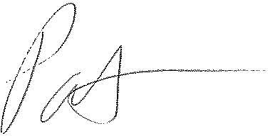

Patrick L. Morse

Senior VP Governmental Affairs

FairPoint Communications

P: 620-227-4409

F: 620-227-8576