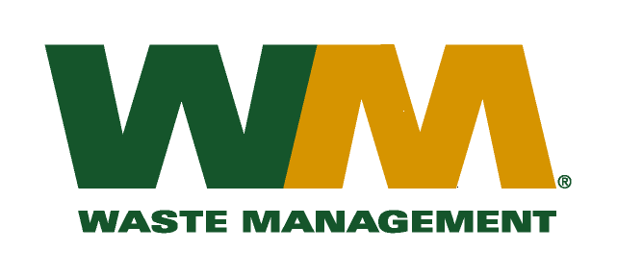

August 12, 2010

Washington Utilities and Transportation Commission

Chandler Plaza Building

1300 S. Evergreen Park Drive SW

P.O. Box 47250

Olympia, WA 98504-7250

Subject: Waste Management – Northwest, a division of Waste Management of Washington, Inc. (G-237); Tariff # 17

Enclosed is substitute page number 2 to the above-referenced tariff in Docket No.TG-101220. This substitute tariff page is being submitted in order to correct a clerical error. Please do not re-docket

Very truly yours,

Mike Weinstein

Senior Pricing Manager, Pacific Northwest Market Area