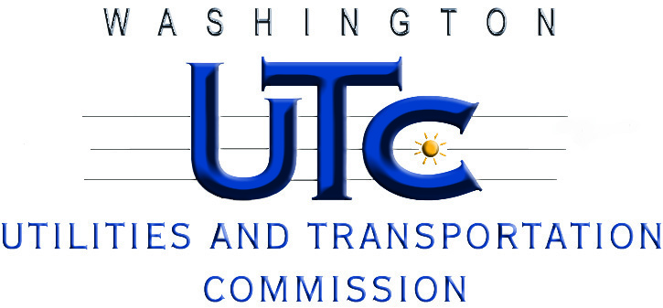

**UT-120052**

**Workshop on Lifeline Issues**

**Agenda**

**February 22, 2012**

**9:30-10:00**

1. **UTC Commissioners’ Opening Remarks**
2. **UTC Telecom Director’s Opening Remarks**

*William Weinman*

*Assistant Director*

*Regulatory Services, UTC*

**10:00-11:00**

1. **Overview of the FCC Lifeline and Link Up Reform Order (FCC 12-11)**

*Kimberly Scardino*

*Deputy Division Chief, Telecommunications Access Policy Division*

*FCC's Wireline Competition Bureau*

1. **Questions and Answers**

**11:00-11:30**

1. **Washington Telephone Assistance Program: Past, Present and Future?**

*Olga Walker*

*Program Manager, Office of Programs and Policy*

*Economic Services Administration*

*Department of Social & Health Services*

**11:30-12:00**

1. **Implementation Timeline for the FCC Lifeline Reform Order**

*Mark Reynolds*

*Director*

*West Region, Regulatory Affairs*

*CenturyLink Corporation*

**12:00-1:00**

**Lunch Break**

**1:00-1:20**

1. **Wireless Lifeline-Only ETC Perspective**

*Brooks Harlow*

*Lukas, Nace, Gutierrez & Sachs, LLP*

**1:20-1:40**

1. **Challenges Presented by the New FCC Lifeline Requirements**

*Elaine Divelbliss*

*Senior Counsel*

*Sprint Nextel Corporation*

**1:40-2:00**

1. **Impact of FCC Lifeline Reform Rule on the Wireless Industry**

*Stephen Athanson*

*Regulatory Counsel*

*TracFone Wireless Inc.*

**2:00-2:15**

**Break**

**2:15-3:45**

1. **Discussion of Future Lifeline Issues in Washington State**

*Jing Liu*

*Regulatory Services, UTC*

1. **Discussion**

**3:45-4:00**

1. **What’s Next?**

*William Weinman*

*Assistant Director*

*Regulatory Services, UTC*