October 18, 2017

Steven V. King, Executive Director and Secretary
Washington Utilities and Transportation Commission
1300 S. Evergreen Park Dr. SW
P. O. Box 47250
Olympia, Washington 98504-7250

RE: Washington Utilities and Transportation Commission v. Waste Control, Inc.
Commission Staff’s Response to Request to Correct the Record
Docket TG-170724

Dear Mr. King:

In May 2017, Commission Motor Carrier Safety Investigator Francine Gagne conducted a routine safety investigation of Waste Control, Inc. (Waste Control). While inspecting one of the Waste Control’s vehicles Ms. Gagne documented an Out-of-Service violation of Title 49 CFR Part 393.25(f) – stop lamp violation. The vehicle was placed Out-of-Service consistent with the North American Standard Out-of-Service Criteria.

A $100 penalty was assessed on July 10, 2017. The commission denied Waste Control’s request for mitigation on September 5, 2017, and Waste Control paid the penalty in full on September 11, 2017.

On October 9, 2017, Waste Control wrote to the commission providing additional details regarding its formal compliance program, contesting the language in the penalty assessement. The $100 penalty assessment states “. . . Waste Control has no formal compliance program . . .” Waste Control requests that the docket be corrected to reflect that the company does in fact have a formal compliance program.

After further researching the matter, staff acknowledges that Waste Control does have a formal compliance program in place.

If you have any questions please contact Francine Gagne, Motor Carrier Safety Investigator, Transportation Safety at fgagne@utc.wa.gov or (360) 664-1231.

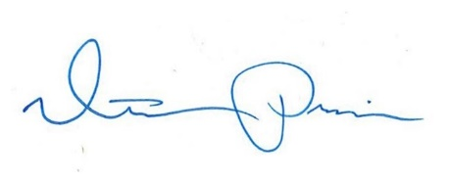
Sincerely,

Mathew Perkinson
Motor Carrier Safety Manager

