June 30, 2014

Steven V. King, Executive Director and Secretary
Utilities and Transportation Commission
1300 S. Evergreen Park Dr. SW
P.O. Box 47250
Olympia, WA 98504-7250

RE: Washington Utilities and Transportation Commission v. Tyson Glawe, LLC

Commission Staff’s Response to Application for Mitigation of Penalties TE-141084

Dear Mr. King:

On May 28, 2014, the Utilities and Transportation Commission issued a $200 Penalty Assessment in Docket TE-141084 against Tyson Glawe, LLC for 2 violations of Washington Administrative Code (WAC) 480-30-071, which requires charter and excursion carriers to furnish annual reports to the commission no later than May 1 each year.¹

On June 16, 2014, Tyson Glawe wrote the commission requesting mitigation of penalties (Mitigation Request).² In its Mitigation Request, Tyson Glawe, LLC does not dispute that the violation occurred. The company states, “Because as a small business owner times are hard enough as it is, without having to pay a hundred dollar per day late fees. I feel that is ridiculous. My fees were paid on time, but the report came much later and was confusing and hard to understand.”

It is the company’s responsibility to ensure that the regulatory fee is paid and the annual report is filed by the May 1 deadline. On February 28, 2014, Annual Report packets were mailed to all regulated charter and excursion companies. The instructions for annual report completion page of the annual report informed the regulated company that it must complete the annual report form, pay the regulatory fees, and return the materials by May 1, 2014, to avoid enforcement action.

On May 5, 2014, Tyson Glawe, LLC filed the 2013 annual report and timely paid the required regulatory fees on December 12, 2013. The company has been active since December 10, 2007. No previous violations of WAC 480-30-071 are on commission record. The UTC also recently
UTC Annual Reports
June 30, 2014
Page 2

adopted new rules requiring the annual report to be filed by May 1 while the regulatory fees remained due on December 31. Despite the commission communication regarding these filing changes to all regulated charter and excursion companies, commission staff supports the company’s request for mitigation. Staff recommends a reduced penalty of $25 per day for a total penalty assessment of $50.

If you have any questions regarding this recommendation, please contact Amy Andrews, Regulatory Analyst, at (360) 664-1157, or aandrews@utc.wa.gov.

Sincerely,

Sondra Walsh, Director
Administrative Services

ATTACHMENT A
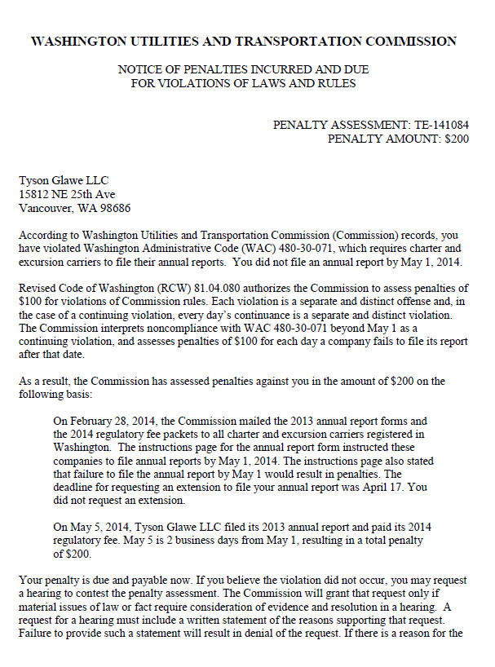

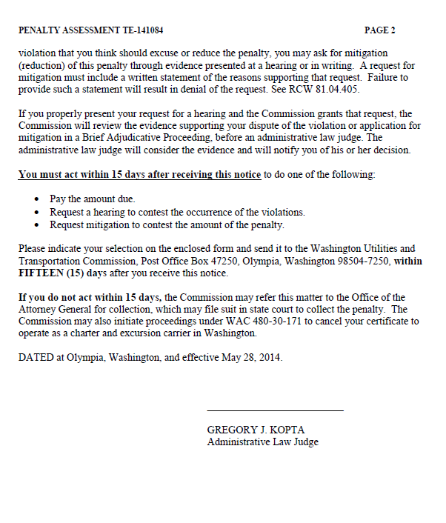

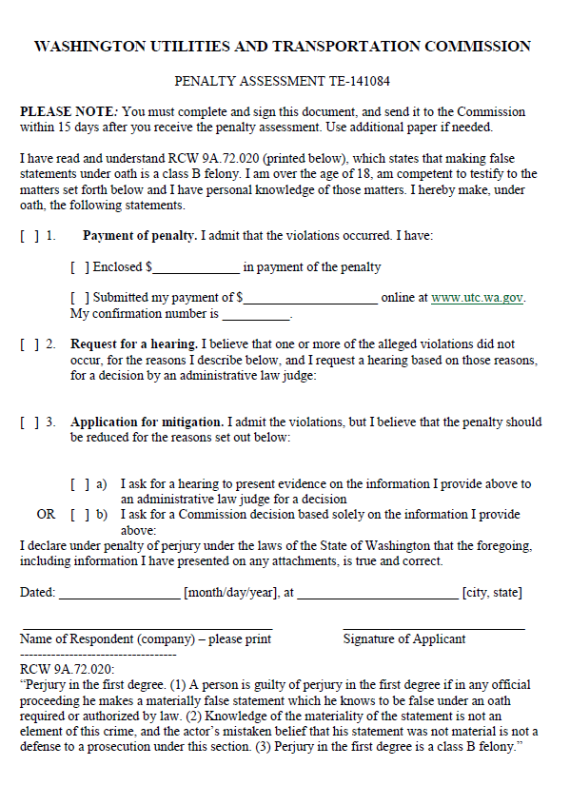

ATTACHMENT B
