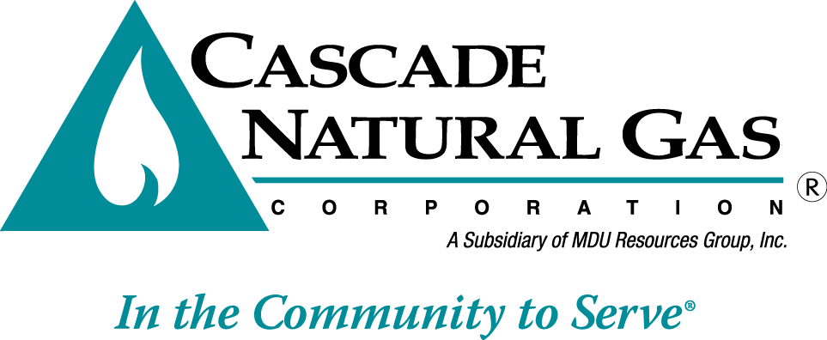 | 8113 W. GRANDRIDGE BLVD., KENNEWICK, WASHINGTON 99336-7166  TELEPHONE 509-734-4500 FACSIMILE 509-737-7166  www.cngc.com

August 5, 2015

Mr. Steven V. King
Executive Director and Secretary
Washington Utilities & Transportation Commission
P.O. Box 47250
Olympia, WA 98504-7250

RE: UG-151599 Tariff Revision
Advice No. CNG/W15-07-04

Dear Mr. King:

Cascade Natural Gas Corporation (“Company”) respectfully withdraws its tariff filing of July 31, 2015, Advice No CNG/W15-07-04. The Company is withdrawing its tariff filing in its entirety upon Staff’s request. The Company will not be re-filing the tariff sheet at this time.

Any questions regarding this filing may be directed to Michael Parvinen at (509) 734-4593.

Sincerely,

Pamela Archer
Supervisor, Regulatory Analysis

