Sanger Law PC
1117 SE 53rd Ave. Portland, OR 97215 tel (503) 756-7533 fax (503) 334-2235 irion@sanger-law.com
__________________________________________________________________________________________________________________________________________________________________________________

April 17, 2017

Via E-filing

Mr. Steven V. King
Executive Director
Washington Utilities & Transportation Commission
1300 S. Evergreen Pk. Dr. S.W.
P. O. Box 47250
Olympia, WA 98504-7250

Attn: Filing Center

RE: In the Matter of Public Utilities Regulatory Policies Act, Obligations of the Utility to Qualifying Facilities, WAC 480-107-105
Docket No. U-161024

Dear Mr. King:

Please find the Comments of the Northwest and Intermountain Power Producers Coalition and the Renewable Energy Coalition in the above-referenced docket.

Thank you for your assistance. Please do not hesitate to contact me with any questions.

Sincerely,

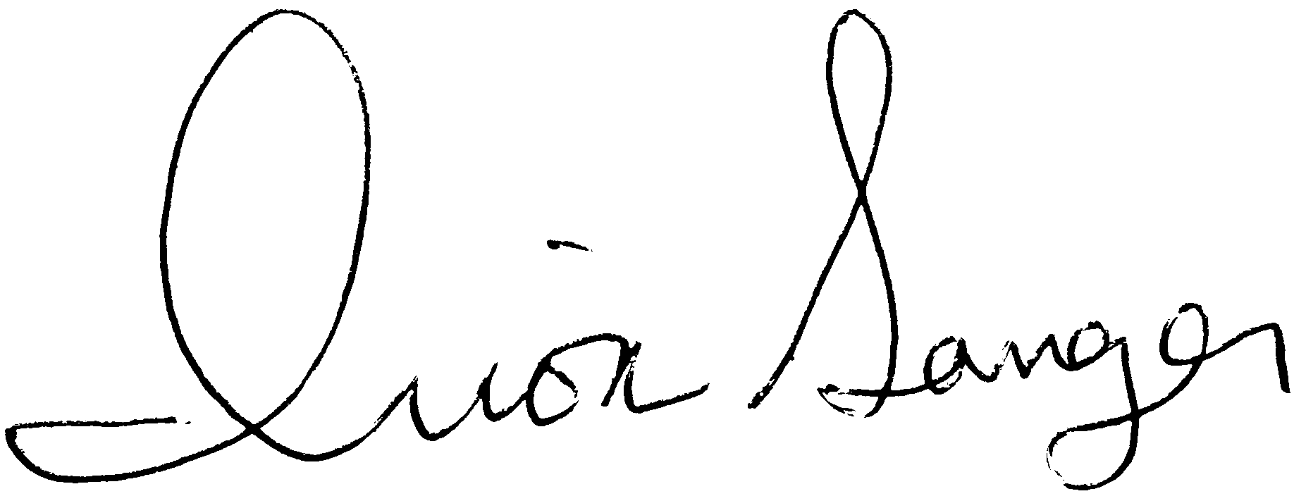

Irion A. Sanger

