SECTION 2

COMPANY OVERVIEW

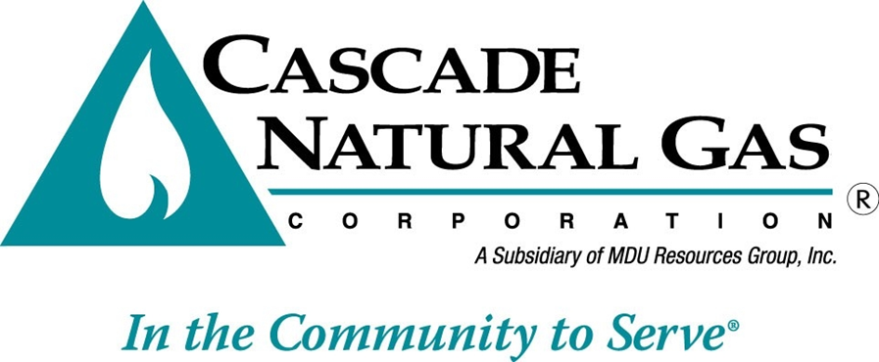

Overview

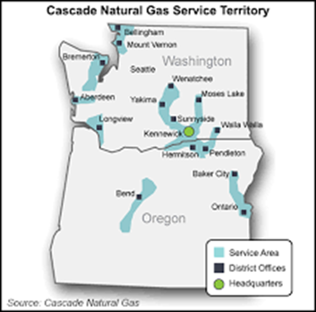
Cascade Natural Gas Corporation delivers retail natural gas service to more than 272,000 customers in nearly 96 communities located throughout Washington and Oregon--68 of which are in Washington and 28 in Oregon. Cascade's service areas are concentrated in the smaller, rural communities in western and central Washington and central and eastern Oregon. The climate of our service territory is almost as diverse as our geographical extension. The western Washington portion of our service territory (nicknamed “I-5 corridor”) has a marine climate similar to many coastal cities of western and southern Europe. Periodic exceptions include the occasional significant snow events, but these are rare. In general, the climate in the western part of service territory is mild with frequent cloud cover, winter rain and warm summers.

The climate of the eastern portion of our Washington service territory has semi-arid conditions with periods of artic cold in the winter and heat waves in the summer.

- Northwest – Bellingham, Mt. Vernon, Oak Harbor/Anacortes, the Kitsap Peninsula, the Grays Harbor area and Kelso/Longview
- Central – Sunnyside, Wenatchee/Moses Lake, Tri-Cities, Walla Walla and Yakima areas.
- Southern – Bend and surrounding communities, Ontario, Baker City and the Pendleton/Hermiston areas.

Over the sixty-six years Cascade has been in business, the Company has gone through many changes. Figure 2.1 provides a snapshot of the Company’s most landmark experiences from the last seven decades.

Figure 2-1: Historical Timeline for Cascade Natural Gas

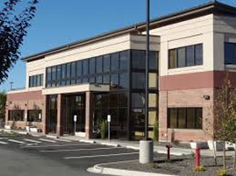

Pipeline and Basin Locations

Cascade purchases natural gas from a variety of suppliers and transports gas supplies to its distribution system via two natural gas pipeline companies. Northwest Pipeline LLC (NWP) provides access to British Columbia and domestic Rocky Mountain gas while the Gas Transmission Northwest (GTN) provides access to Alberta gas. Cascade also holds transportation contracts upstream of these systems on TransCanada Pipeline’s Foothills Pipeline (formerly ANG) and NOVA Gas Transmission Ltd. (also known as NGTL), as well as on Ruby Pipeline and Westcoast Energy, Inc. (Spectra Energy). More information about the pipelines and the supply basins can be found in Section 4 (Supply Resource Planning). Maps of select pipelines can be found in Section 13 (Glossary and Miscellaneous References).

Core vs Non-Core/Bundled vs. Unbundled Service

Since Cascade began distributing natural gas in the Pacific Northwest, the Company has offered its customers a “bundled” natural gas distribution service. This bundled service includes the gas supply which is transported to Cascade’s citygate and the distribution of that gas to the end use Cascade, “bundled-service” customer. Customers receiving traditional bundled services are referred to as core customers.

In 1989, Cascade “unbundled” its rates, and as a result approximately, the Company current has 250 large volume customers who have elected to become "non-core" customers. These customers have made the choice to rely on alternative methods of gas service rather than take the traditional bundled gas supply and pipeline transportation services available to core customers for their gas requirements.

Providing gas supply and transportation capacity resources to non-core customers is not considered part of this Integrated Resource Plan (IRP). As such, resources for serving these customers are separate from the supply and capacity contracts for the core customers who continue to utilize Cascade’s bundled system gas supplies and capacity. Although the resource needs for non-core customers are not included in either the conservation or supply side resource analysis, their contracted peak day delivery is considered in the distribution system planning analysis discussed in Section 9.

For the calendar year ended December 2015, Cascade's residential customers represented approximately 12% of the total natural gas delivered on Cascade's system, while the commercial customers represented approximately 9% and the 500 core market industrial customers consumed approximately 2% of total gas throughput. The remaining 250 non-core industrial customers represented about 77% of total throughput.

Company Organization

Cascade is a subsidiary of MDU Resources Group, Inc., a multidimensional natural resources enterprise traded on the New York Stock Exchange as “MDU.” Cascade is part of the utility group of subsidiaries. MDU Resources Group’s utility companies serve more than 1 million customers. Cascade Natural Gas Corporation distributes natural gas in Oregon and Washington. Great Plains Natural Gas Co. distributes natural gas in western Minnesota and southeastern North Dakota. Intermountain Gas Company distributes natural gas in southern Idaho. Montana-Dakota Utilities Co. generates, transmits and distributes electricity and distributes natural gas in Montana, North Dakota, South Dakota and Wyoming. Figure 2-1 provides a geographical representation of the various services/territories served by MDU Resources, Group.

Figure 2-2: MDU Resources Services and Territory

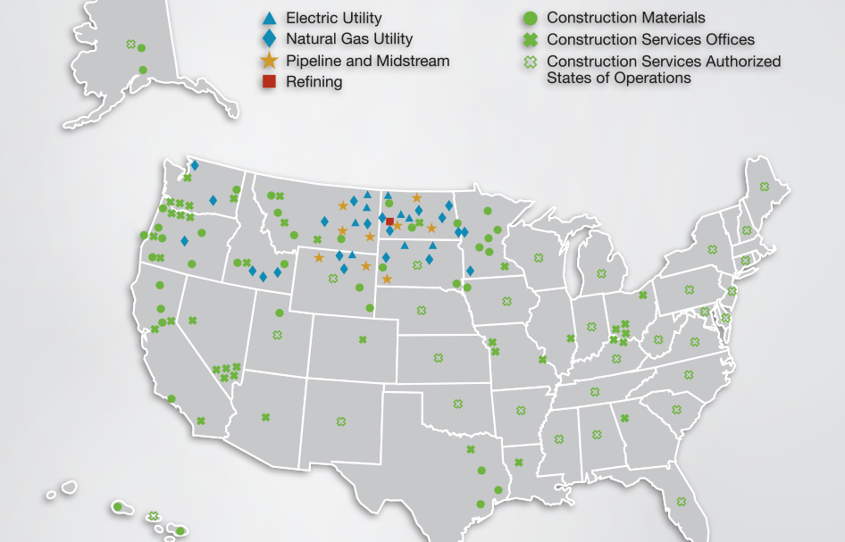

Cascade’s headquarters are located in Kennewick, Washington. Many internal and external stakeholders have developed Cascade’s 2016 IRP. Cascade’s IRP Steering Committee provides oversight and guidance, ensuring the IRP meets all regulatory requirements.

Wikipedia, retrieved July 27, 2016

